**Bijay Khanal**

**Student Number: 219387361**

**CET313 Artificial Intelligence**

**Intelligent Prototype Development**

**Report**

**Introduction**

“Machine Learning is a method of Manipulating and extraction of implicit, previously unknown/known and potential useful information about data”. Machine learning is a varied field whose range is growing daily. It constitutes different classifiers of Supervised, Unsupervised & Ensemble Learning that are utilized for predicting & getting the Accuracy of the provided dataset. So due this reason if I develop the Heart disease Prediction Model Intelligent Prototype using machine learning I can aid in diagnosis of the heart patients (Jindal, Agrawal, Khera, Jain, & Nagrath).

I utilized the Institute of Health Metrics and Evaluation’s Global Burden of Diseases database on cardiovascular disease of Nepal for explaining the most relevant data there is (2017) & stats by age, gender and year from 1990 to 2017. Data are illustrated in the form of percentages or as rates per 100,000 population. In 2017, Cardio Vascular Diseases resulted to 26·9% of total deaths and 12·8% of total DALYs in Nepal. Ischemic heart disease was the mostly CVDs, resulting to 16·4% to total deaths and 7·5% to total DALYs. CVDs incidence and mortality rates have increased from 1990 to 2017, with the weight more on men & in elderly. The main risk factors for CVDs were found out to be high systolic blood pressure, high low density lipoprotein cholesterol, smoking, air pollution, a less consumption of fruits and whole grains (Bhattarai & Aryal, 2020).

Aim:

* Evaluation of the various models and select the best model
* To create a Heart disease Prediction Model by utilizing Kaggle datasets.
* Access to as many individuals suffering from any heart issues
* Help in quick disease diagnosis and detection
* Provide as a great tool which the hospitals can have at their disposal.
* Decrease price of a diagnosis such as various kinds of test was done to know whether the diagnosis should be done or not based on their parameters such as age, blood pressure, heartbeat rate, cholesterol, etc. and evaluate if a patient has HEART DISEASE or not.

The data set taken is Heart disease Dataset (Comprehensive) from Kaggle website.It has more than 11 common features. It is the biggest heart disease dataset which is accessible for research purpose. The five datasets used for its curation are:

#### Database: #####of instances:

1. Cleveland: 303
2. Hungarian: 294
3. Switzerland: 123
4. Long Beach VA: 200
5. Stalog (Heart) Data Set: 270

##### Total 1190 (Heart Disease Dataset (Comprehensive))

Medical personnel a lot of time can’t predict the heart disease of a patient and it is about 67% maximum that they could predict since presently the diagnosis is carried out based on the similar symptoms analysed from already diagnosed patients. Some of the works carried out in this sector are:

R. Perumal et al. developed a heart disease prediction model using the Cleveland dataset of 303 data instances through feature standardization and feature reduction using PCA, where they identified and utilized seven principal components to train the ML classifiers. They concluded that LR and SVM provided almost similar accuracy values (87% and 85%, respectively) compared to that of k-NN with 69%. C. B. C.

Latha et al. performed a comparative analysis to improve the predictive accuracy of heart disease risk using ensemble techniques on the Cleveland dataset of 303 observations. They applied the brute force method to obtain all possible attribute set combinations and trained the classifiers. They achieved a maximum increase in the accuracy of a weak classifier of 7.26% based on ensemble algorithm, and produced an accuracy of 85.48% using majority vote with NB, BN, RF, and MLP classifiers using an attribute set of nine attributes.

D. Ananey-Obiri et al. developed three classification models, namely, LR, DT, and Gaussian naïve Bayes (GNB), for heart disease prediction based on the Cleveland dataset. Feature reduction was performed using single value decomposition, which reduced the features from 13 to 4. They concluded that both LR and GNB had predictive scores of 82.75% and AUC of 0.87. It was suggested that other models, such as SVM, k-NN, and random forest, be included.

N. K. Kumar et al. trained five machine learning classifiers, namely, LR, SVM, DT, RF, and KNN, using a UCI dataset with 303 records and 10 attributes to predict cardiovascular disease. The RF classifier achieved the highest accuracy of 85.71% with an ROC AUC of 0.8675 compared to the other classifiers (Reddy & Elamvazuthi, 2021).

**Reflection on the prototype identification**

From researching about development of other intelligent systems of the similar type and the knowledge which I acquired from doing all the tasks and exercises assigned to me in this module I found out the process of development of any machine learning project is similar. This is a project which deals with structured data. The data set which is taken will consist of various features variables and a target variable which is what we are going to predict. In gist, the process of how this machine learning model actually works is that it learns about the patterns present in the feature variables and how these patterns can be used to predict target variable. For this we first collect the data which is in this case the data set of heart data set. Then the definition of the problem is known (whether it is classification or regression anything else).We analyze the data which is present in the data set. The recognition of the features on which we model is carried out. There can be a feature which has more priority than remaining features. Then evaluation of the predictions given as outcomes by various models is carried out and selecting of the best models out of them all is done for production. The final part is performing the experiment on the selected best model. This whole is an iterative process. From the extensive research which I have performed in this module I have found about the different tools needed to carry out the steps of data modeling, data analysis (which includes the evaluation and feature selection), machine learning i.e. modeling and experimenting. Along with preprocessing, visualization and feature scaling, I have also carried out the Tuning the hyperparameters, Feature importance, Confusion matrix, Cross validation, Precision, Recall, F1 score, Classification report, ROC curve and Area under the curve (AUC)

**Prototype development**

Heart disease prediction intelligent prototype (sid312axn, 2020)

Navigated to the git link provided <https://github.com/sid321axn/Heart-Disease-Prediction-Using-Machine-Learning-Ensemble>

Looked at the dataset used in this repository (sid321axn, 2020)

Searched in Kaggle for the same dataset

Downloaded the dataset and uploaded it in the jupyter notebook.

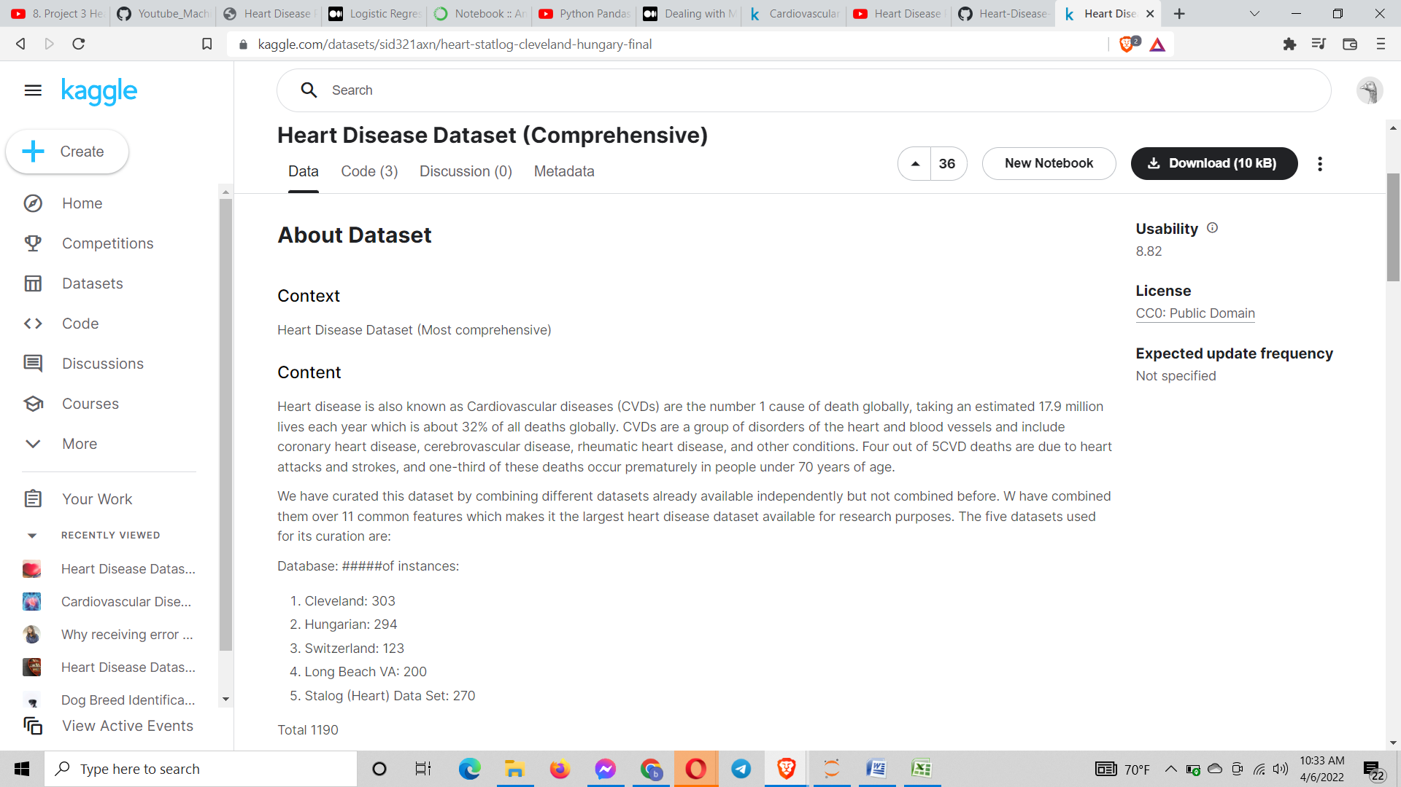

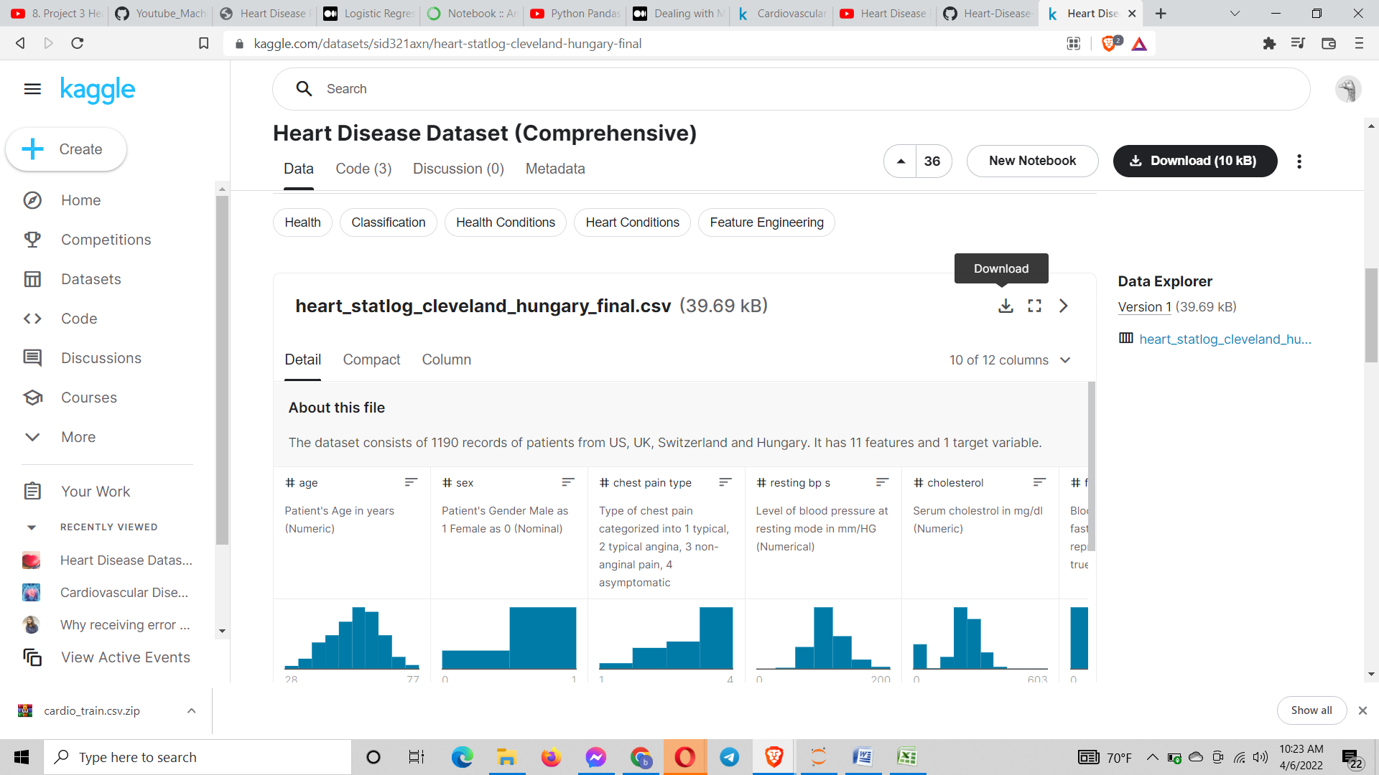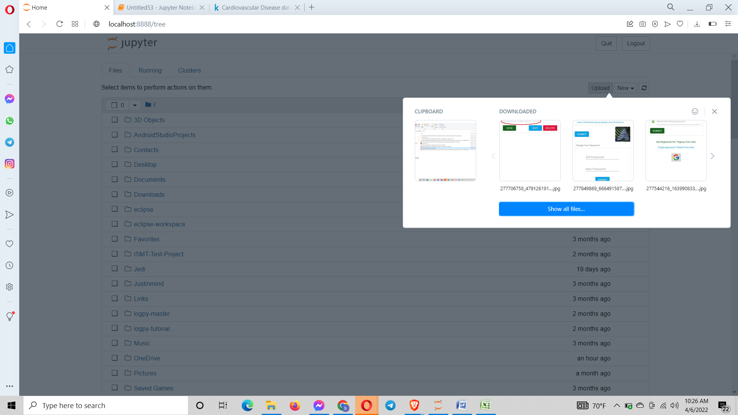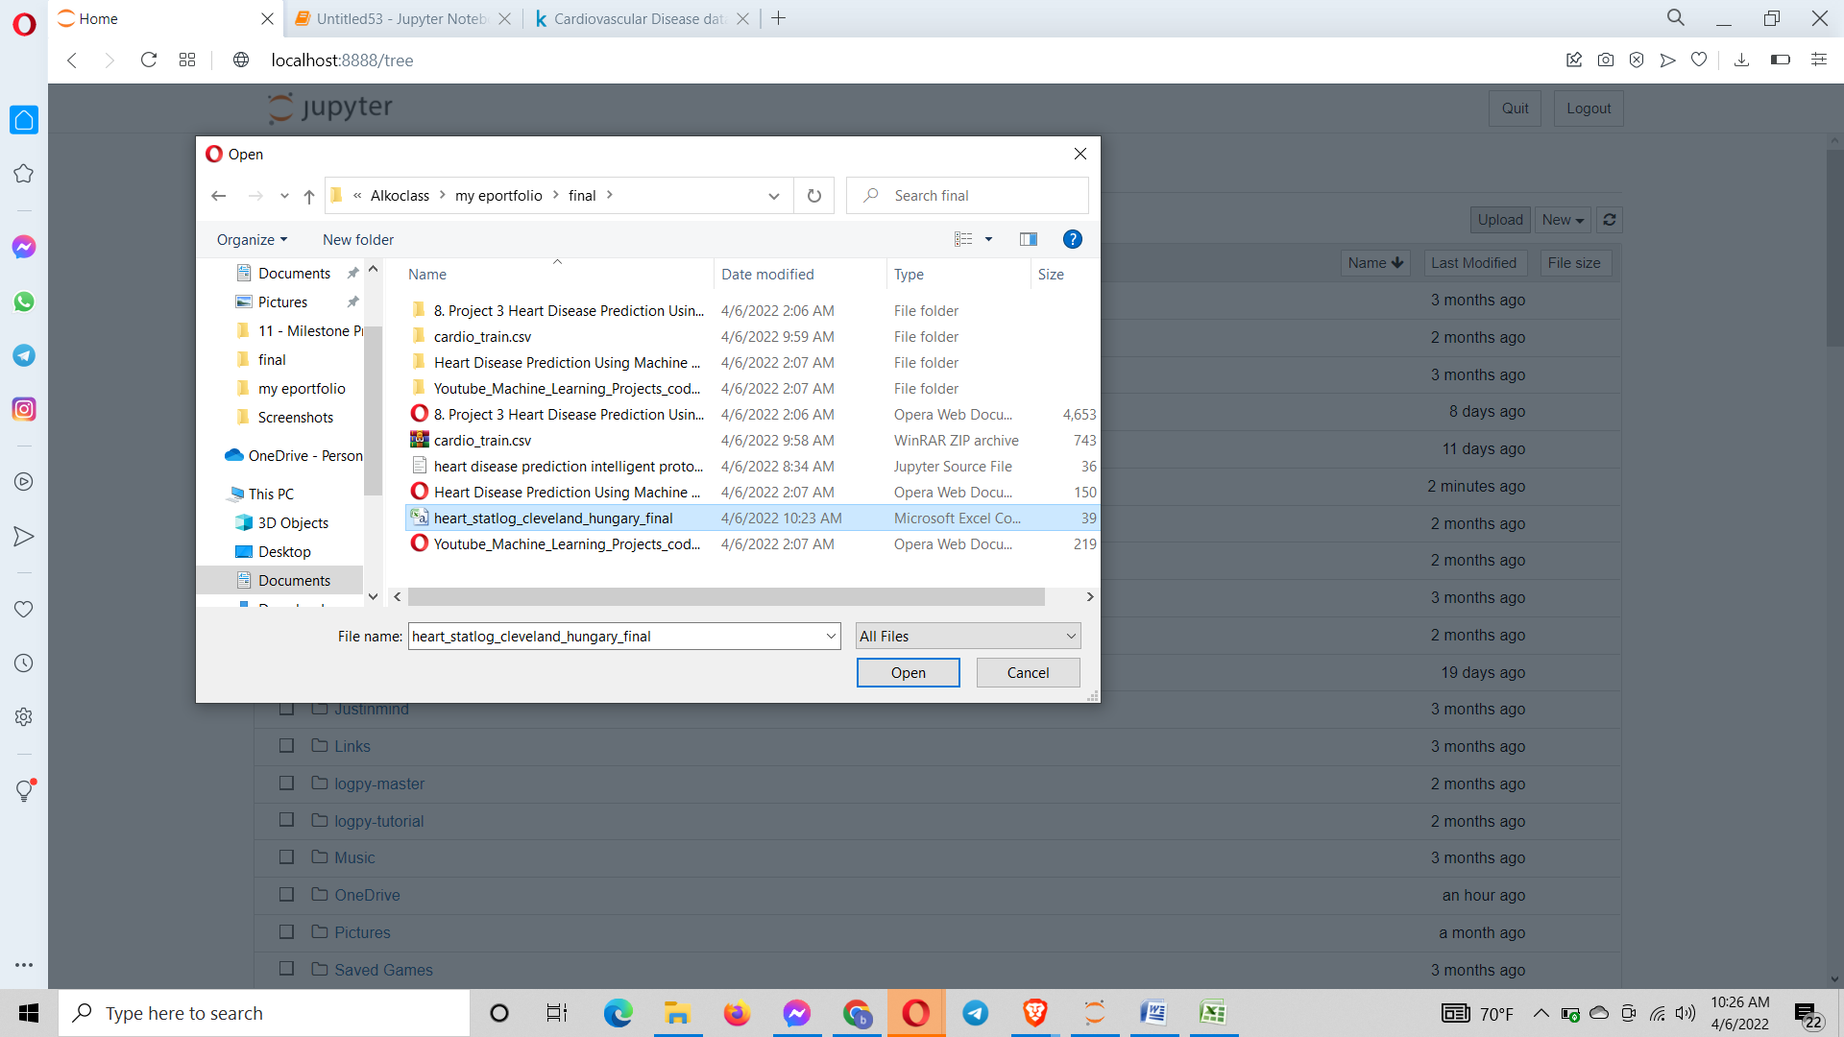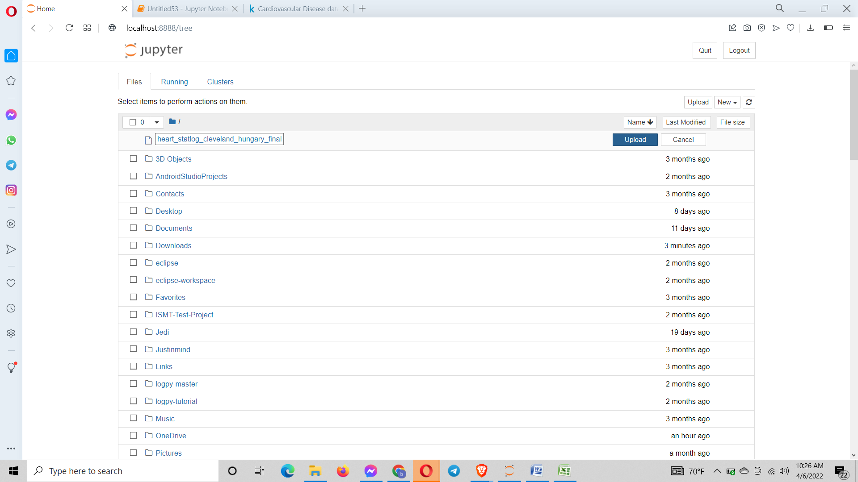

Analysed if there are any null data values in the dataset using the head(),describe() and info(). (Pandas) (Pandas) (Pandas) (plus2net)

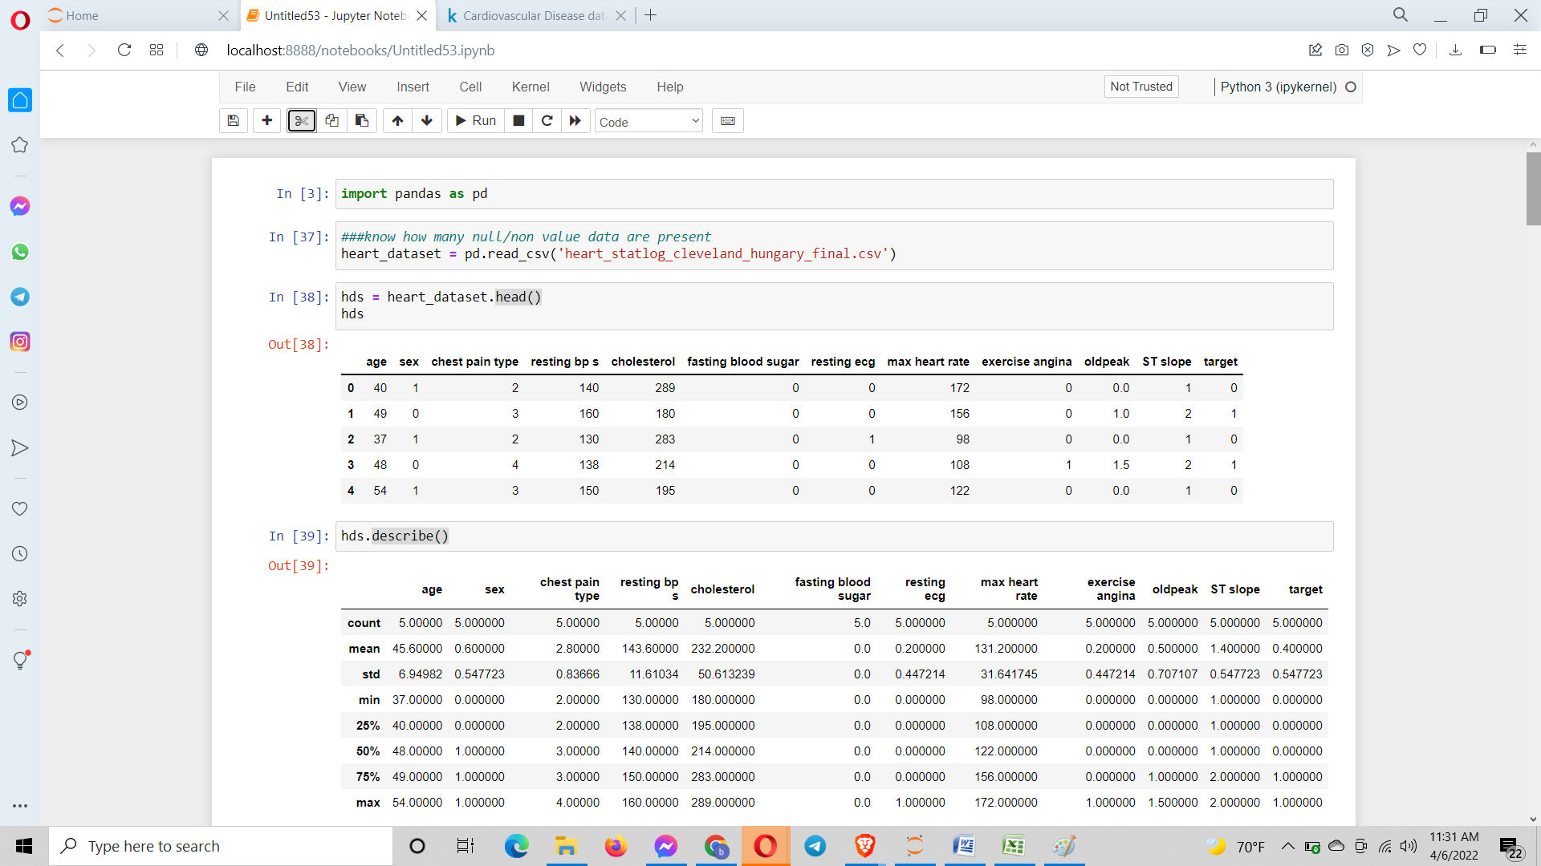

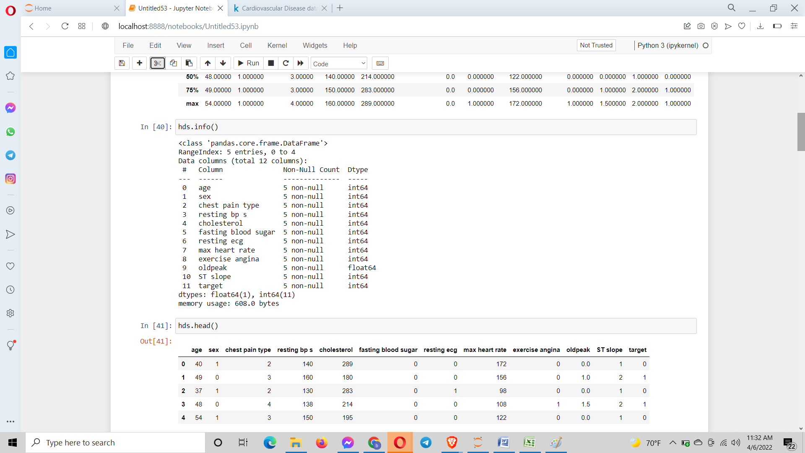

Observed if there are any null values.

(htt20)

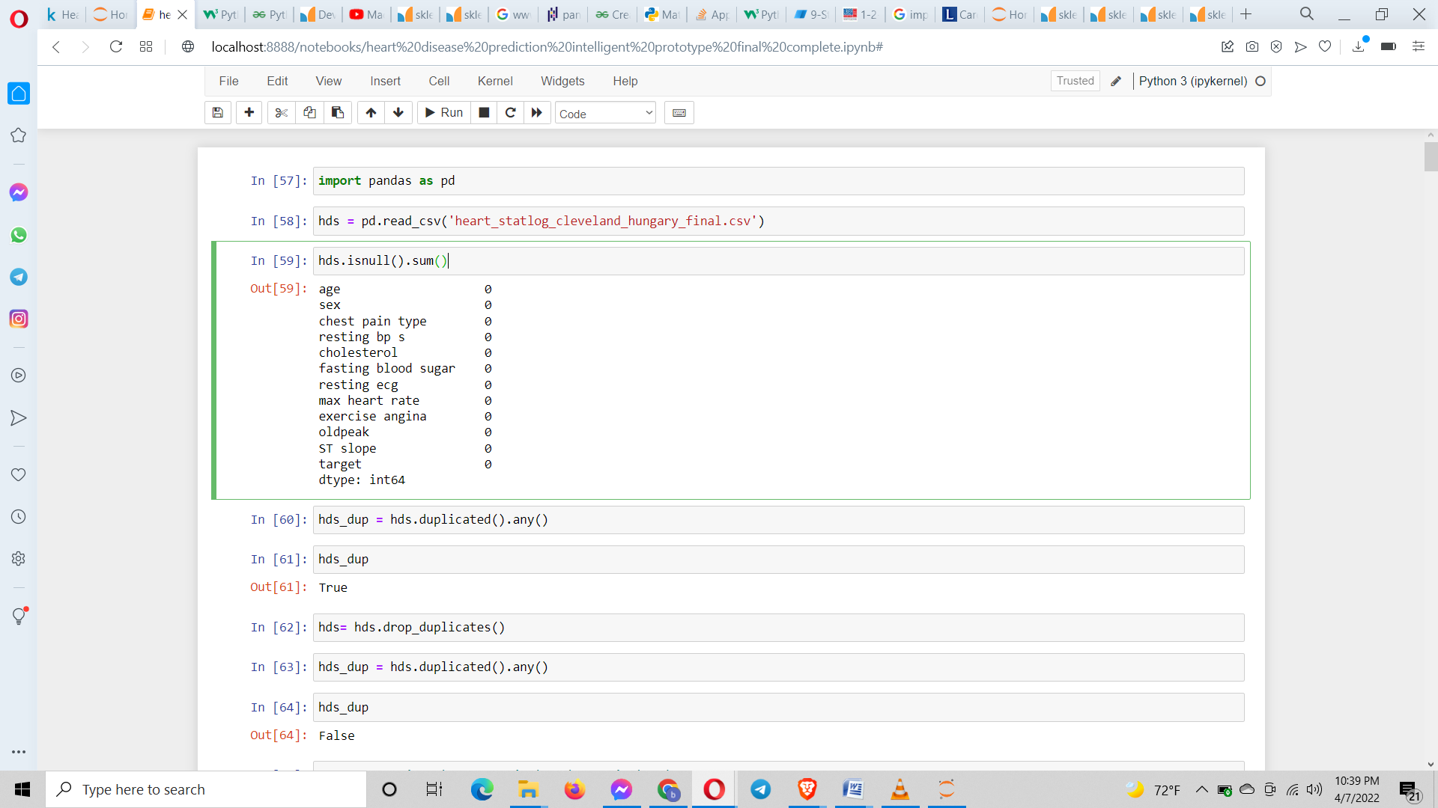

Searched for any duplicated data values in the dataset using duplicated( (Pandas))

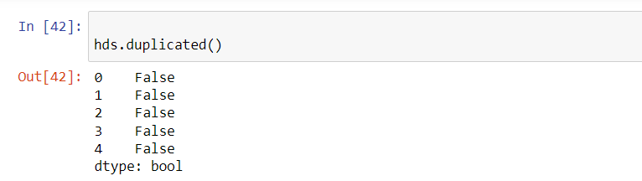

Saw if there are any null values present (pandas)

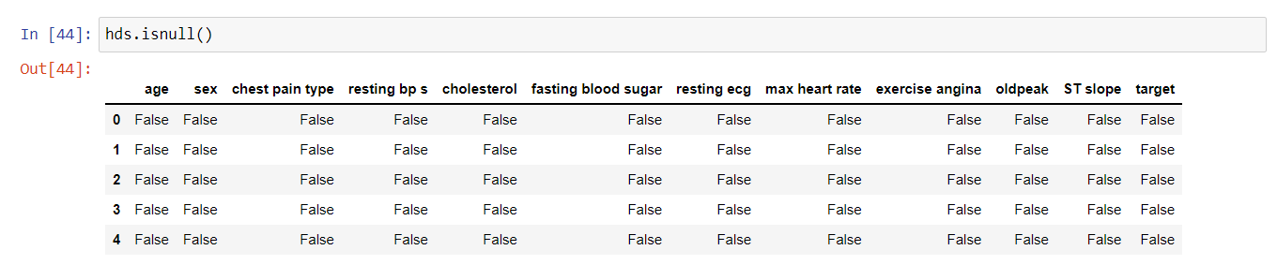

**Separating the columns to categorical and numerical data:**

The columns needs to be distinguished as categorical or numerical. Categorical columns have categorical data and numerical columns consist of numerical values. For this I create two lists cat_data and num_data. The for loop is used and from the list of columns in the dataset I append the categorical columns in cat_data and remaining in the num_data. I can observe that there are 9 categorical columns and 5 numerical columns. The condition determining this is based on the unique values of each column in the dataset. If the unique value of a column is <= 10 then that column is taken as categorical column otherwise it is taken as numerical column (Pandas) (Pandas) (ask python) (w3schools) (Pandas) (Kartikayabhutani, 2018) (k, Geeks for geeks, 2022) (Youtube, 2018)

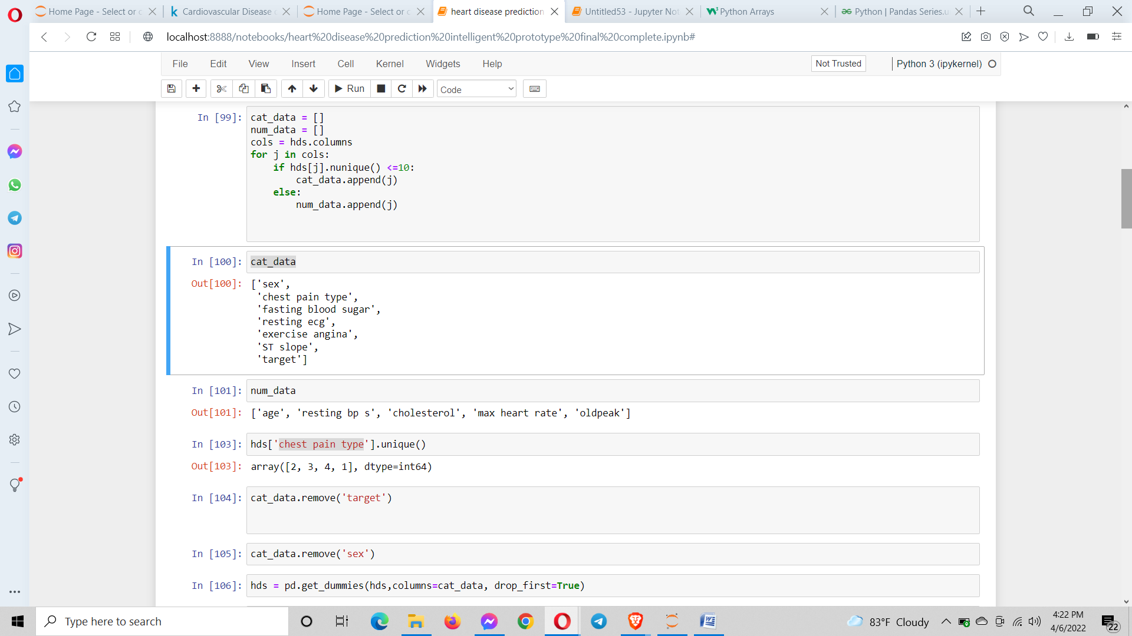

**Categorical to binary encoding:**

Now I need to convert the dataset into binary vectors (0s and 1s) so that the model can understand it. When analyzing the dataset, in the column sex (which can only be either of the two: male or female) and target the values inside them are already converted to binary vectors. Dummy variables are needed for all the categorical data columns except the sex and target. From the above screenshot I can observe that the chest pain column has a total of 4 values (2, 3, 4 and 1). So the chest pain type column array has 4 unique values 2, 3, 4 and 1. As I can see the values are not in any order. Models recognize order. So I do a categorical value conversion to binary vector which are given in the screenshot below. There are 4 values of chest pain type hence if a binary vector of it is to be made then it would be like this:

2 3 4 1

1 0 0 0

0 1 0 0

0 0 1 0

0 0 0 1

Here in the 1st row if I know the values of the binary converted values of 3, 4 and 1 as 2 then I can easily predict the binary converted value of 2. Even though the variables are independent if I know the values of 3 of them then the value of the 4th one can be predicted. This is known as a dummy variable trap. To remove this I eliminate the 1st column of the 0th index. So that is why I gave the parameter drop_first=True inside the get_dummies() function. This function is used to create dummy values of a column. Coincidently dummy values of other remaining categorical columns also get created (Chudasama, 2021) .

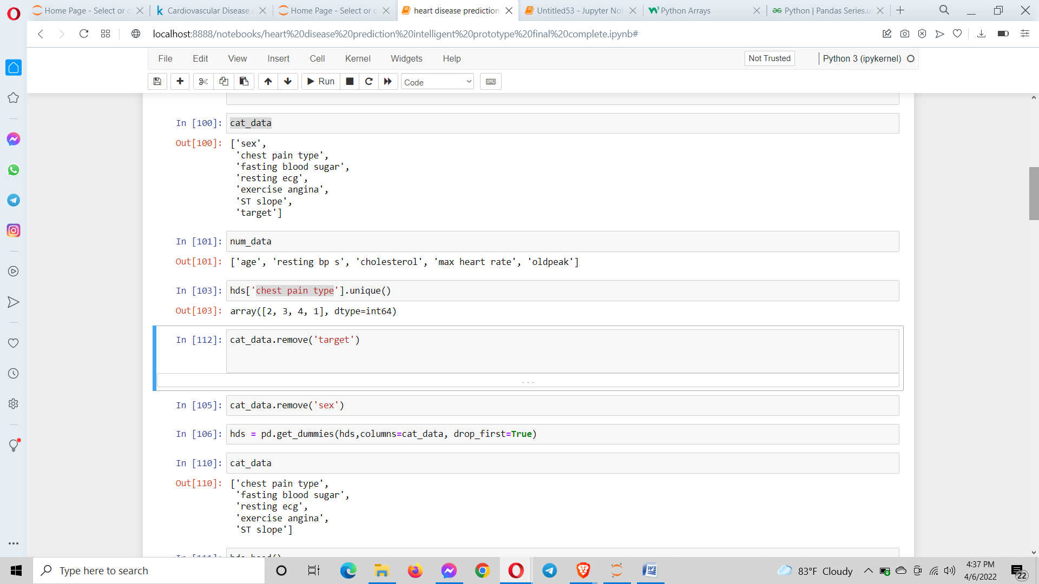

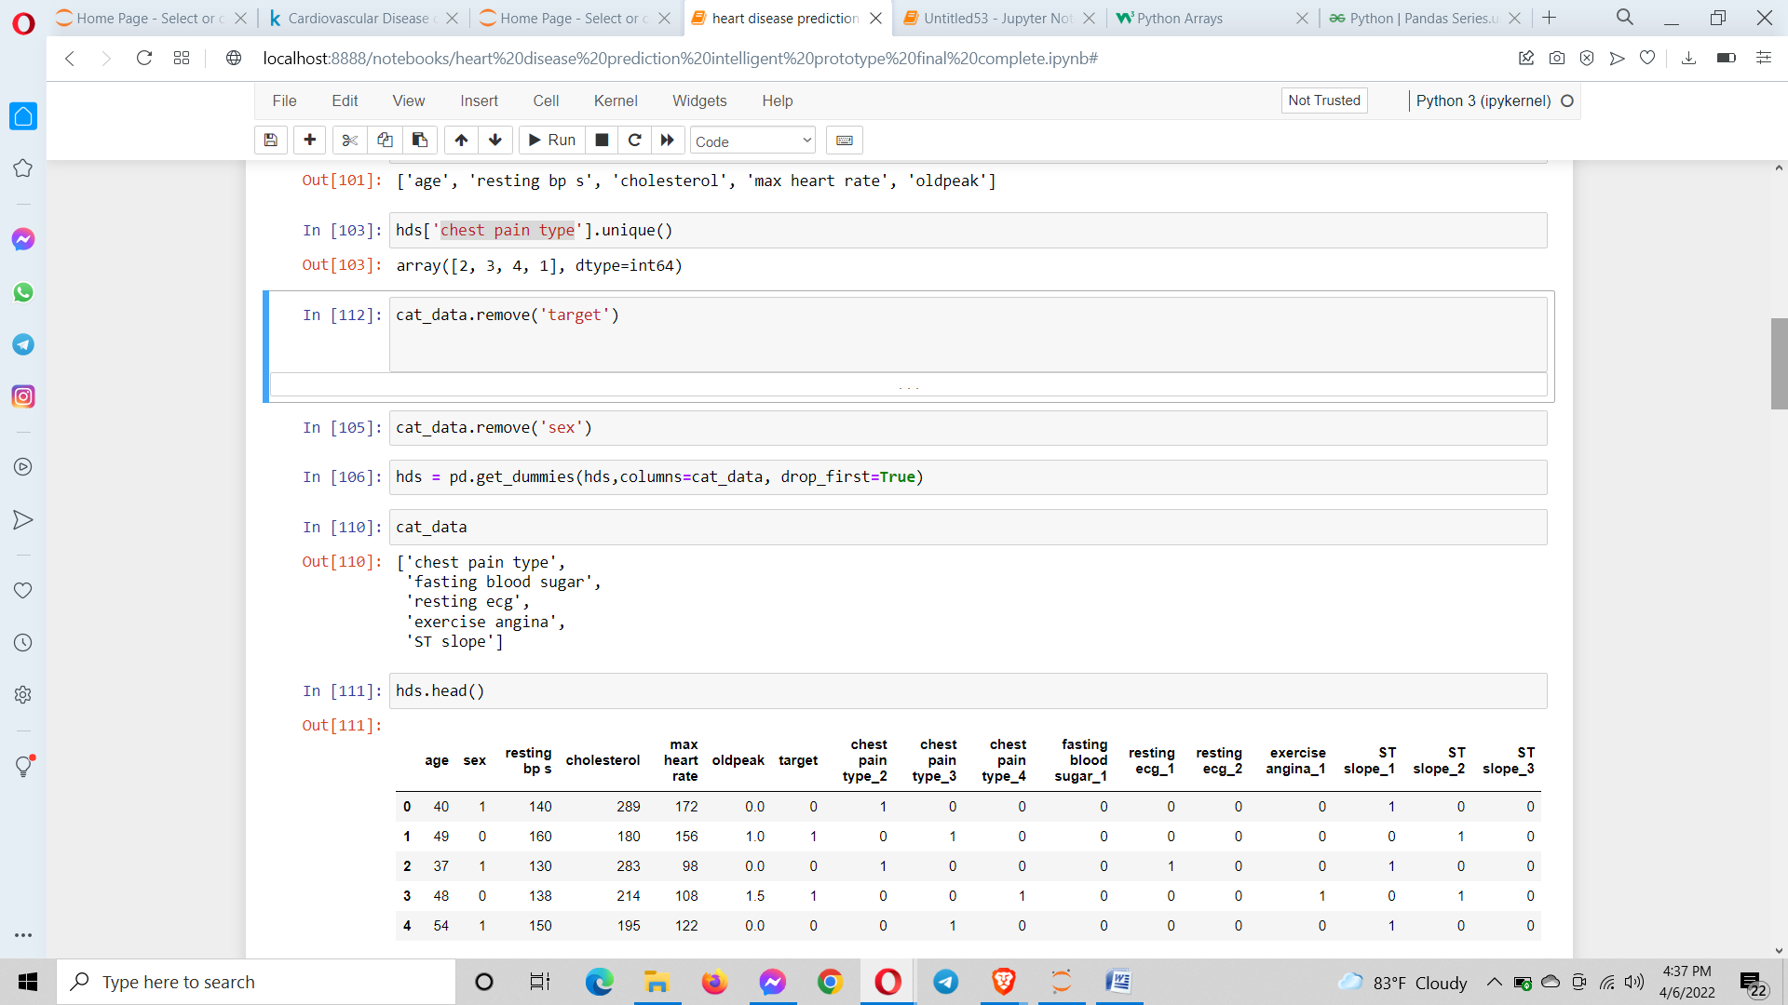

**Feature Scaling:**

The feature scaling means to scale values in the columns(features) so that the models can use it easily without less bias. The ML algorithms calculate distances among values. The more the difference betIen the values the greater the larger values have precedence over the smaller values while the finding of the distances. The Linear algorithms like SVM and Linear Regression need feature scaling. In the above screen shot the extra columns which have just been added by encoding have their values already scaled. The non linear algorithms don’t need feature scaling. They do not need any scaling. The scaling is needed for the remaining columns (excluding sex and target columns). After the features are scaled the values will fall in betIen either -4 to 4, -3 to 3, -2 to 2 or -1 to 1 as shown in the screenshot below:

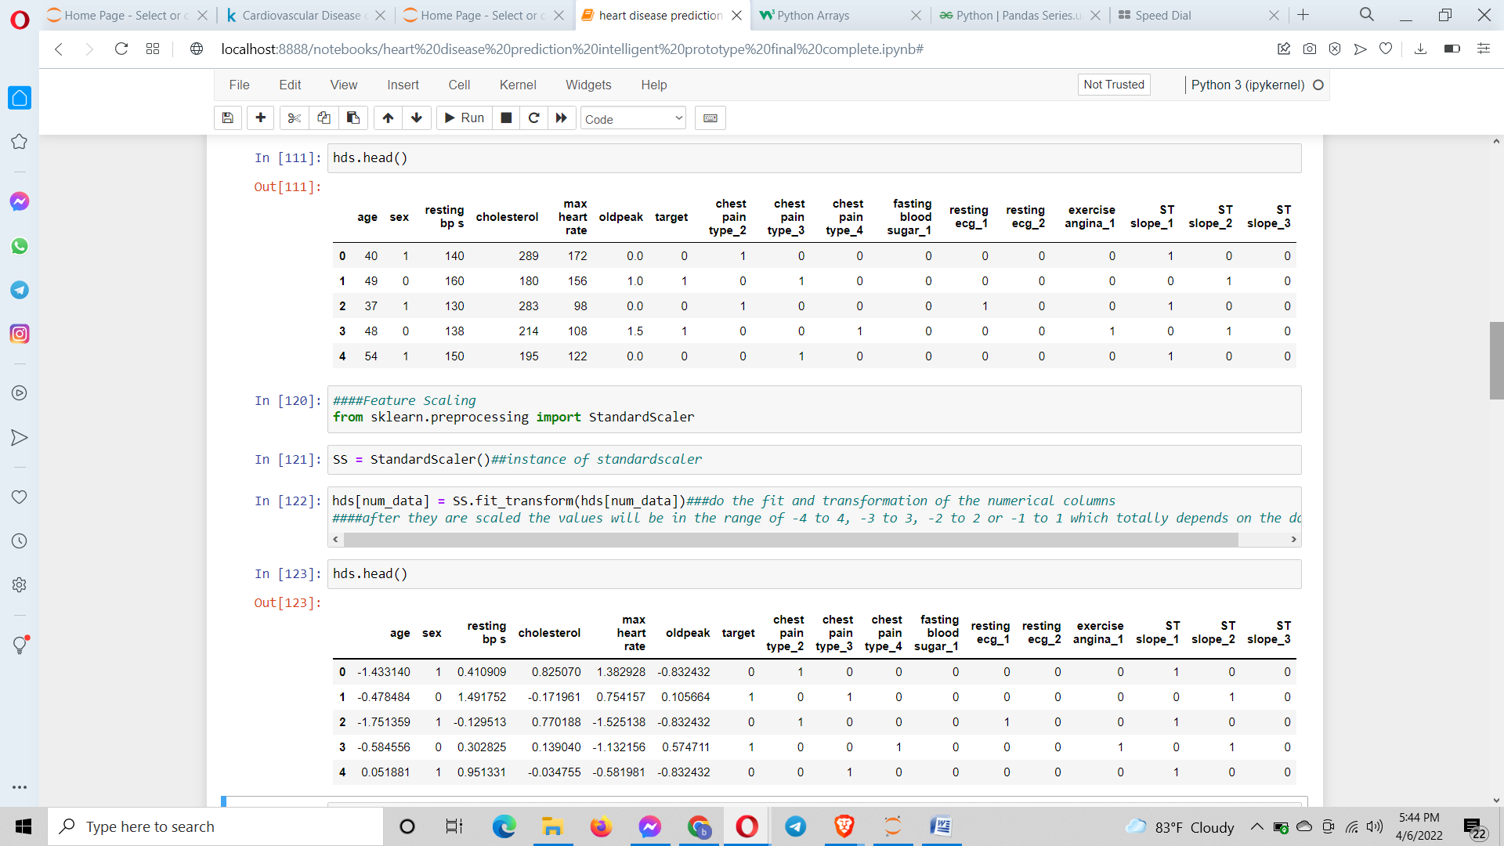

From scikit learn I imported the standardscalar class. Then I instanciate it and apply the fit_transform() function in the numerical data columns (Chudasama, Geek culture, 2021) (Bhatt, 2021).

**Splitting the data set in test and train set:**

I split the data commonly into 80% training set and 20% testing set via [train_test_split() function](https://scikit-learn.org/stable/modules/generated/sklearn.model_selection.train_test_split.html).. The test size is the size of the test in percent. Here I have given test data size as 0.2 ie. 20%. The value ranges betIen 0 and 1. I can see the shape of the splitted data using test.shape. The drop function is used to delete a column and axis = 1 represents a column. The random state parameter is kept 38 so every time the train test split is made the same data points are going to appear for feeding it to the model for training the model. So every time the line is ran it will generate the same data points

(734, 16) (184, 16) (734,) (184,)

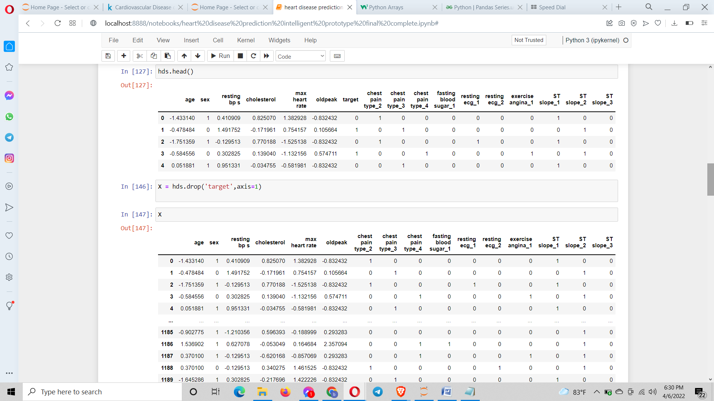

The screenshot above gives the independent variables.

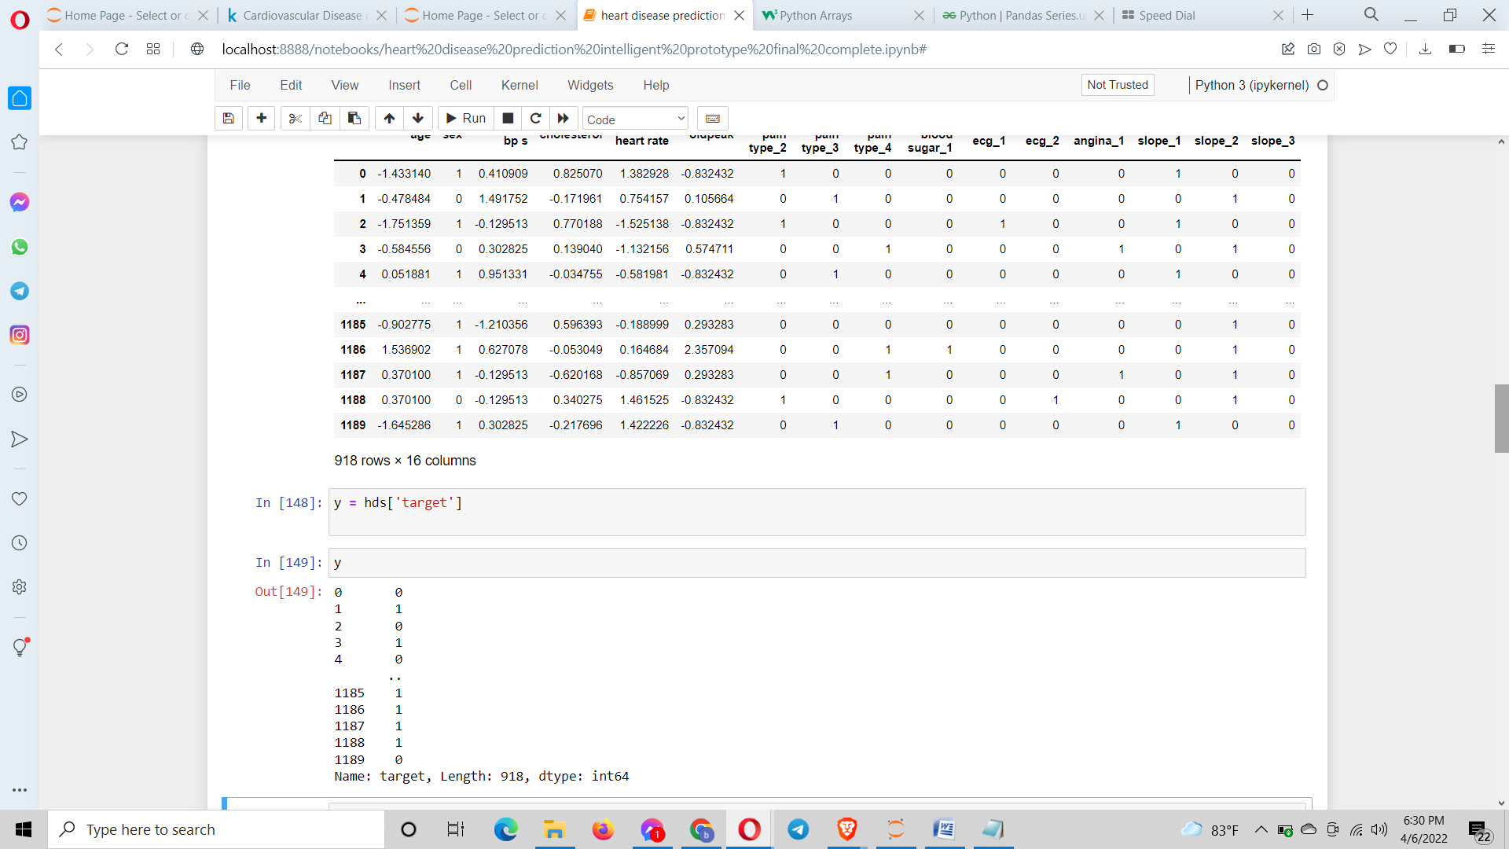

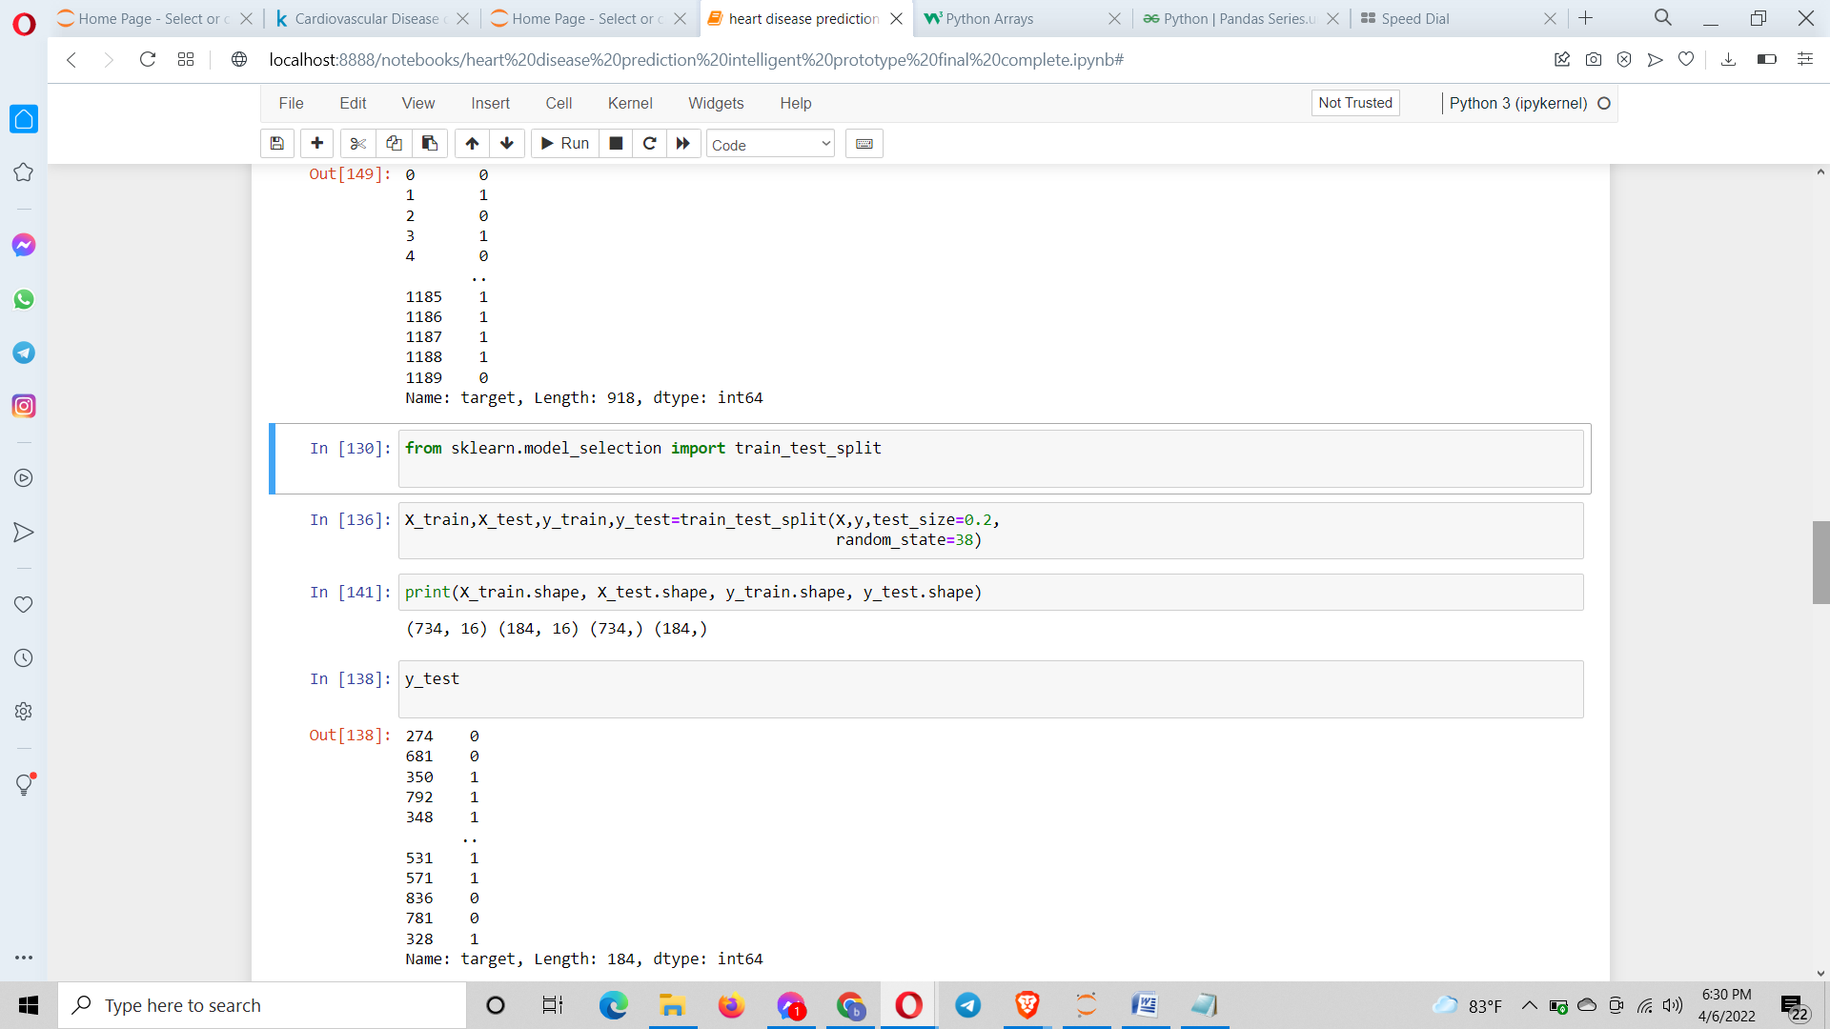

The target is the dependent variable as shown in the screenshot above.

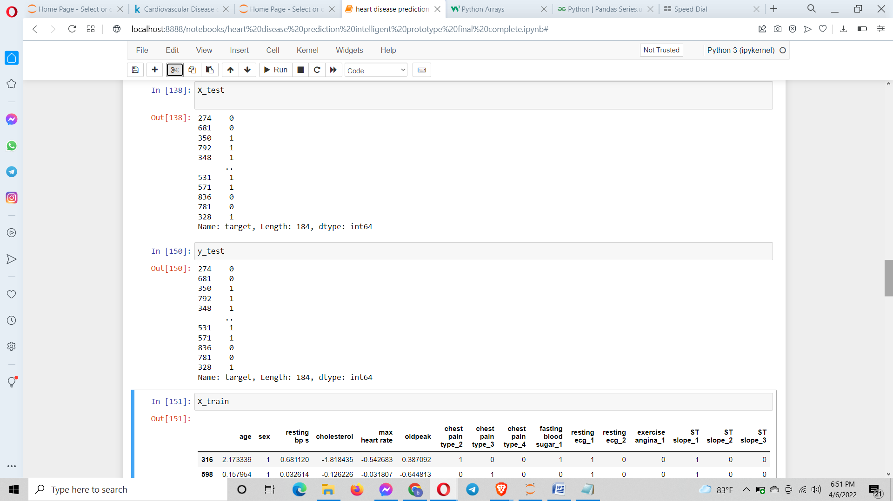

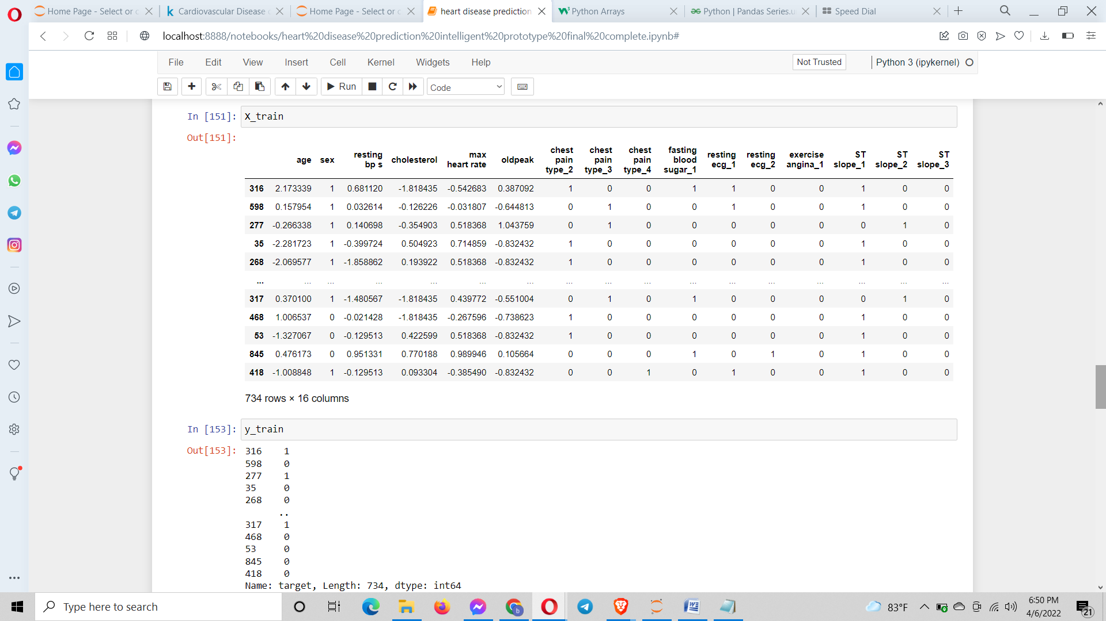

The above two screenshots gives us the train set and test set which I have split.

I have used the following models for the prediction:

logistic regression

SVC

Decision tree classifier

Random forest

Knearest Neighbour classifier

The accuracy of all these are taken and the decision is made as to which model is the most accurate in predicting the heart disease.

In the target column there are either of the two 0 or 1.

0 = an individual with no heart disease

1 = an individual with heart disease

The target variable is thus categorical. So it’s a classification problem.

For all the I imported the following classes from the sklearn library. They are as follows:

from sklearn.linear_model import LogisticRegression

from sklearn import svm

from sklearn.tree import DecisionTreeClassifier

from sklearn.ensemble import RandomForestClassifier

from sklearn.neighbors import KNeighborsClassifier

Then instantiation is done followed by the fitting of the train and test set. Then the actual training is done by using the fit() method to which the train data set X_train and y_train training sets are provided. Then the prediction is done by using the predict() on the test data set. The model hasn’t seen the data stored in the test data set X_test. So for the prediction by the model we supply it these data. The prediction result got from the model will be stored inside the yhat variable. Then from sklearn library I imported the accuracy_score class which is used to evaluate the predictions that the model has resulted using the accuracy_score() function. This function is given the predicted results yhat and the test data set y_test. It then compares them and results the accuracy of the prediction. The accuracy I got of all the models are displayed on the screenshots (Scikit learn) (Scikit learn) (Scikit learn) (Scikit learn) (Scikit learn) (Scikit learn) (scikit learn).

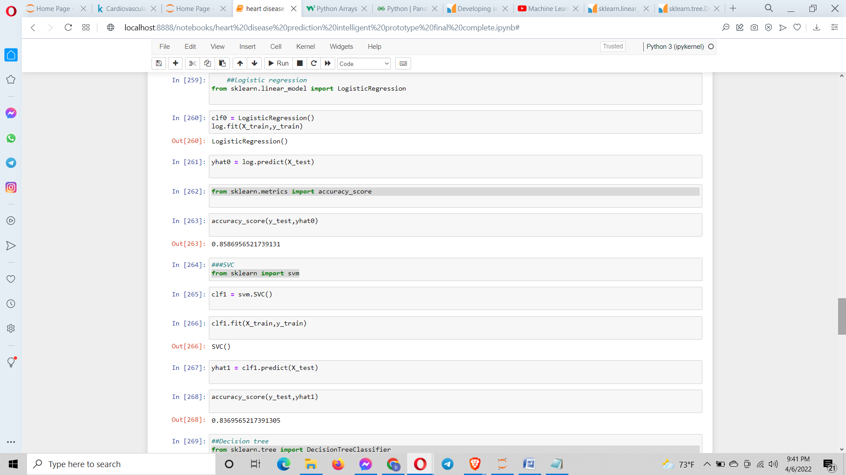

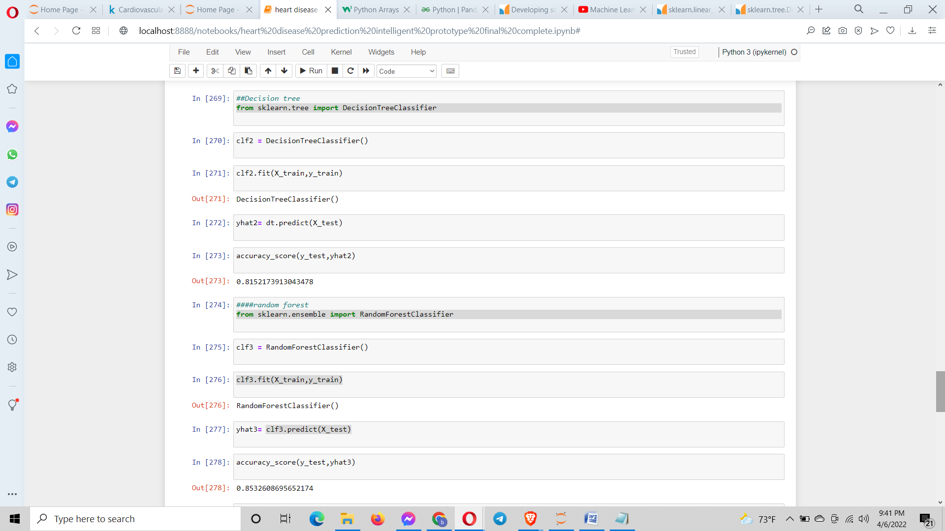

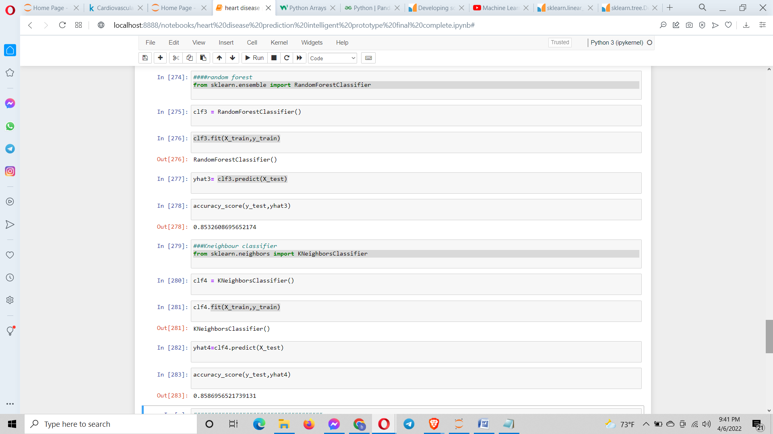

The accuracies of all the models are:

0.8586956521739131(85.86%) => Linear Regression

0.8369565217391305(83.69%) => SVM

0.8152173913043478(81.52%) => Decision Tree

0.8532608695652174(85.32%) => Random Forest

0.8586956521739131(85.86%) => KNN

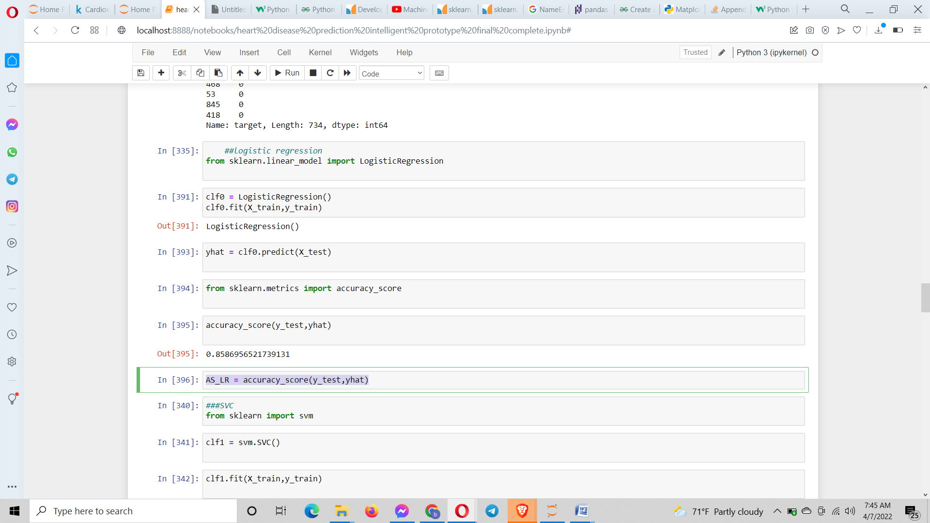

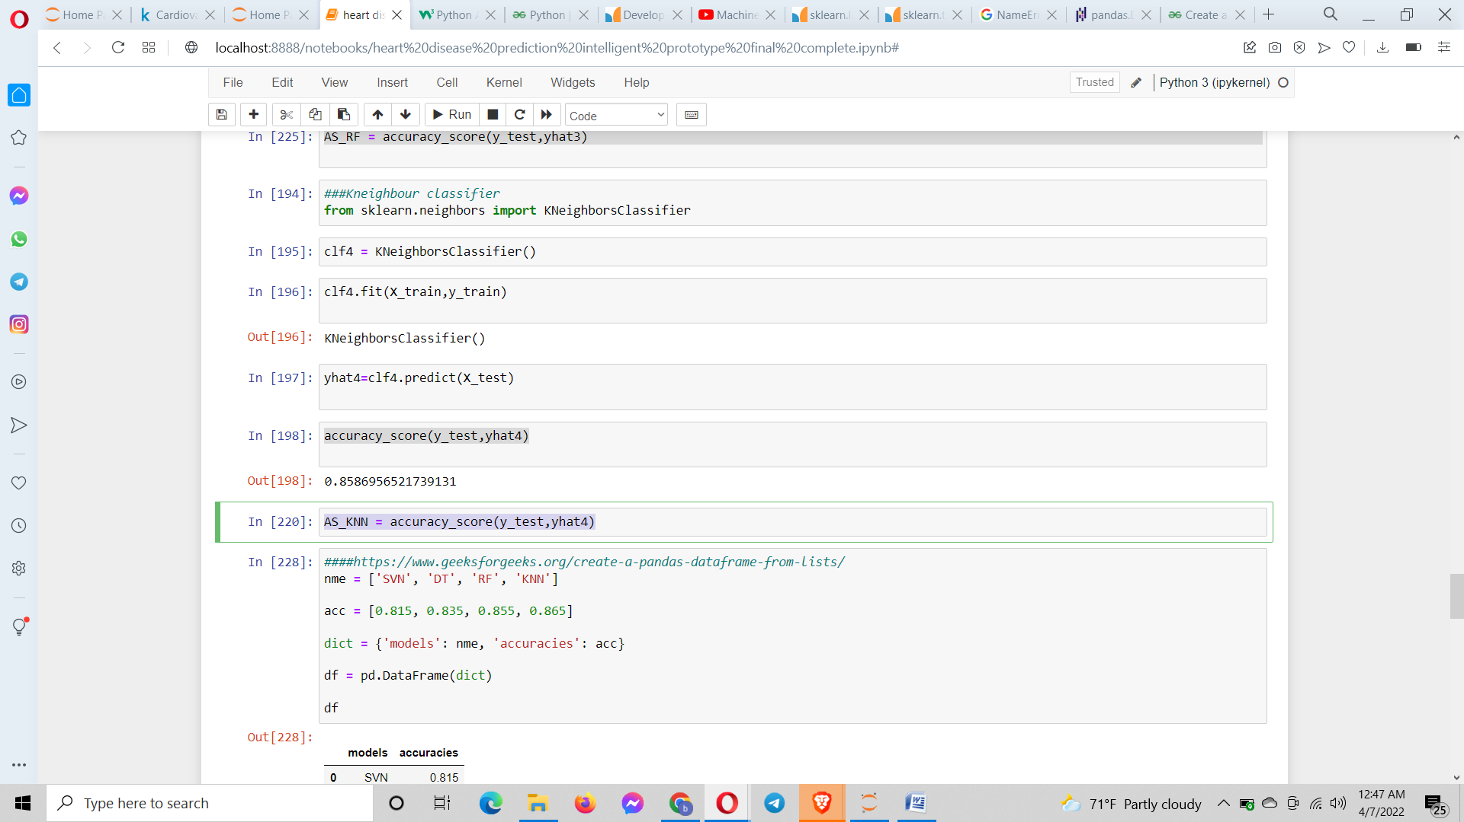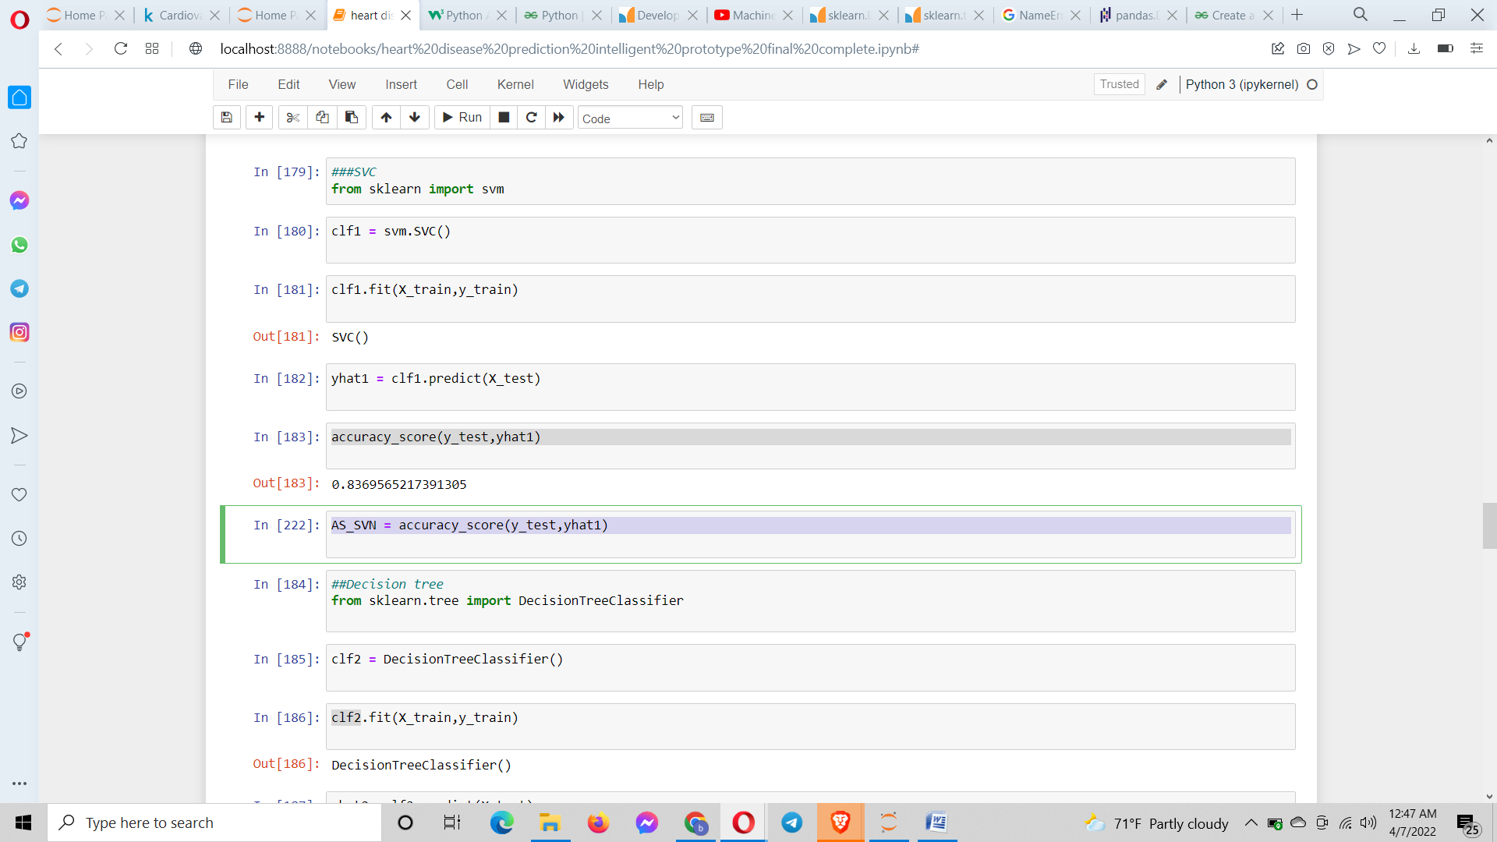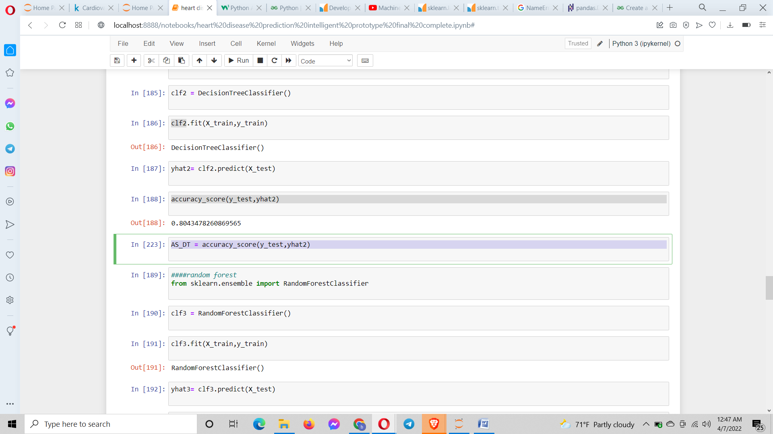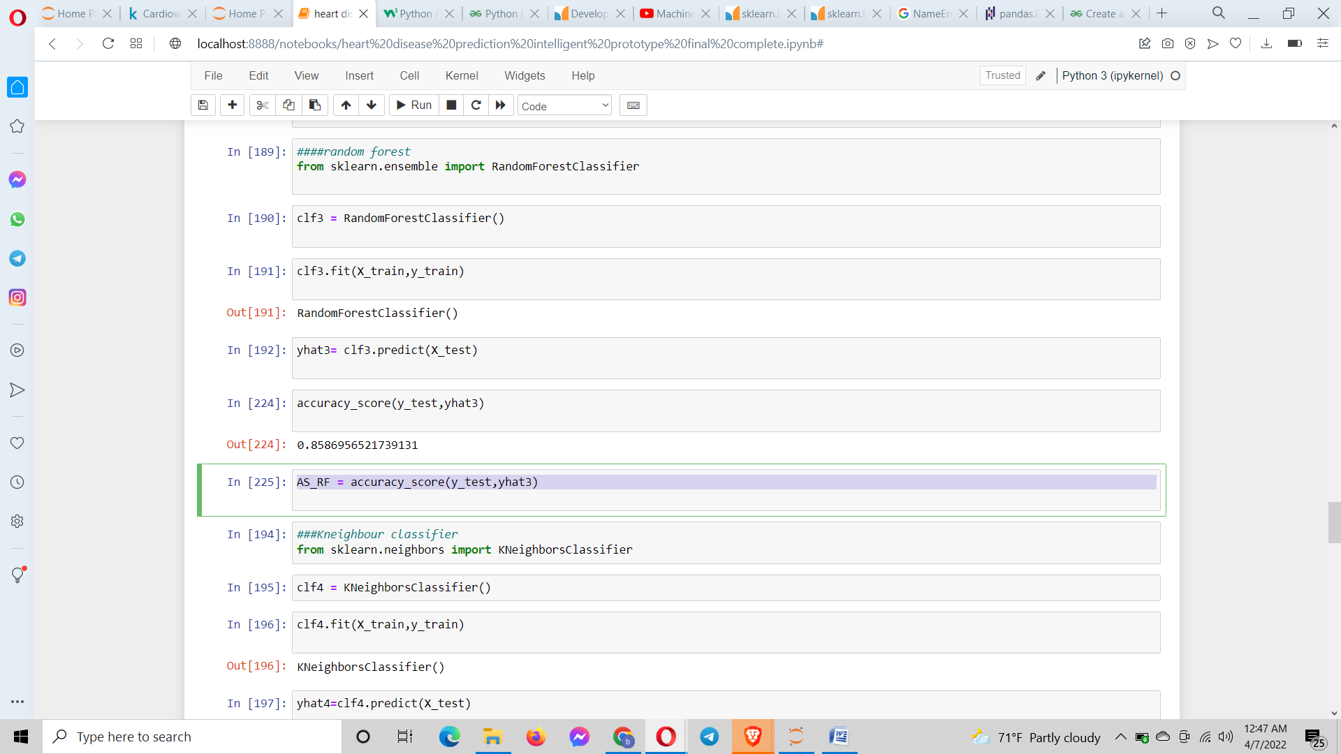

I stored all the accuracies values inside different variables.

**Visualization** (k, 2021)

Now I took 5 models Linear regression, SVM, Decision Tree, Random Forest and KNN to compare their accuracies via visualization. I stored their names in one list and appended values of variables inside another empty list. Then created dictionary of lists and I used lists in dictionary to create dataframe (Data visualization) (Stack overflow).

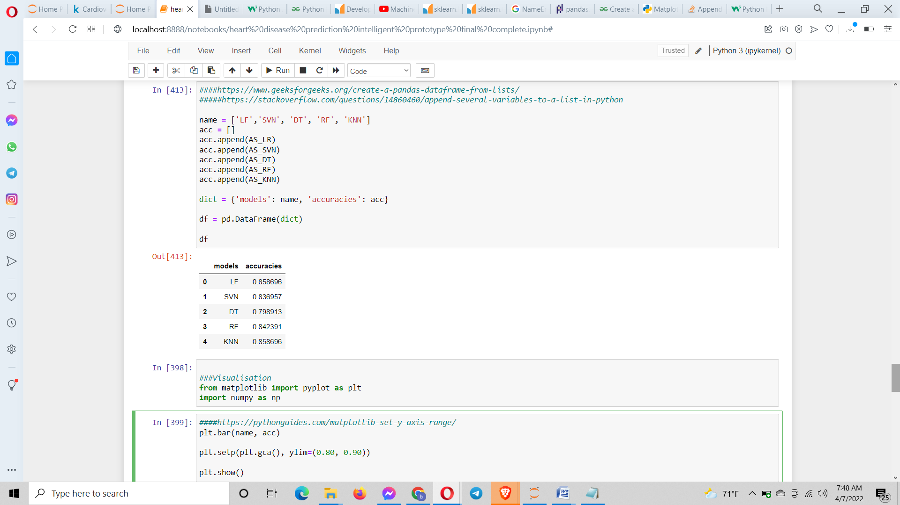

I then visualized the accuracies in a bar histogram shown below. First the necessary import like matplotlib and numpy were done and then the bar was plotted. Here the bar obtained clearly shows that either Linear regression or KNN gave the greatest accuracy from among the models.

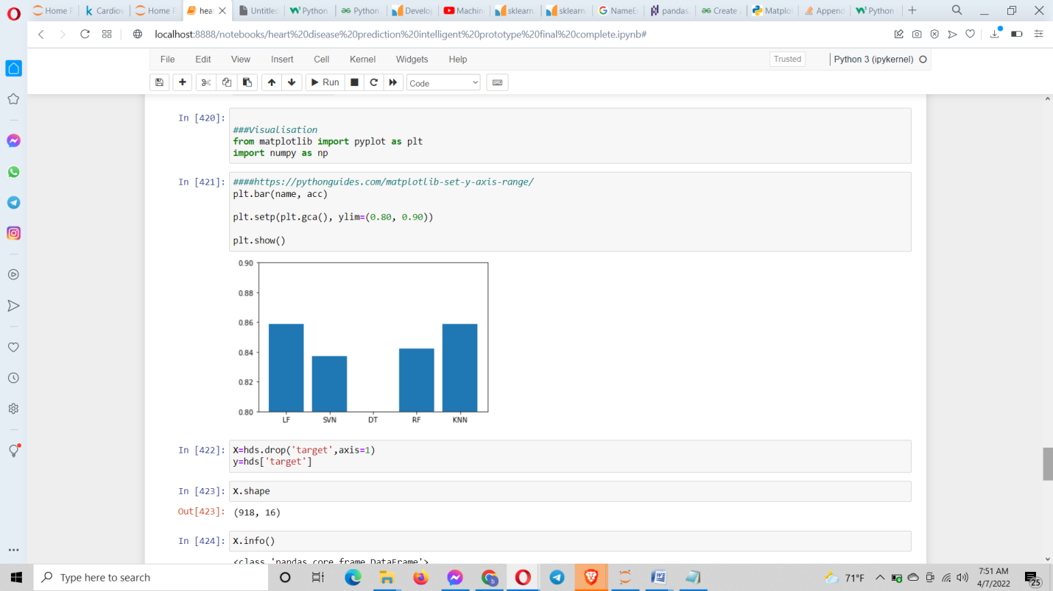

I chose KNN as my best model for prediction. Now that I found my best model I will use it to train on an entirely new dataset. Now I divided the data set into test and train dataset. The target variable is loaded into the X variable and rest of the variables are loaded in the y variable. Since there are a total of 16 columns(variables) in the dataset one target variable goes into X(which can be displayed using the shape function) and the rest 15 goes into y (Kunal Naaik, 2020) .

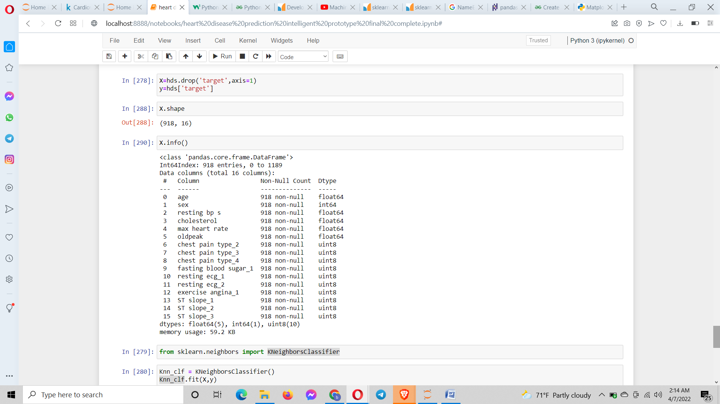

Here I created a new data set to predict.

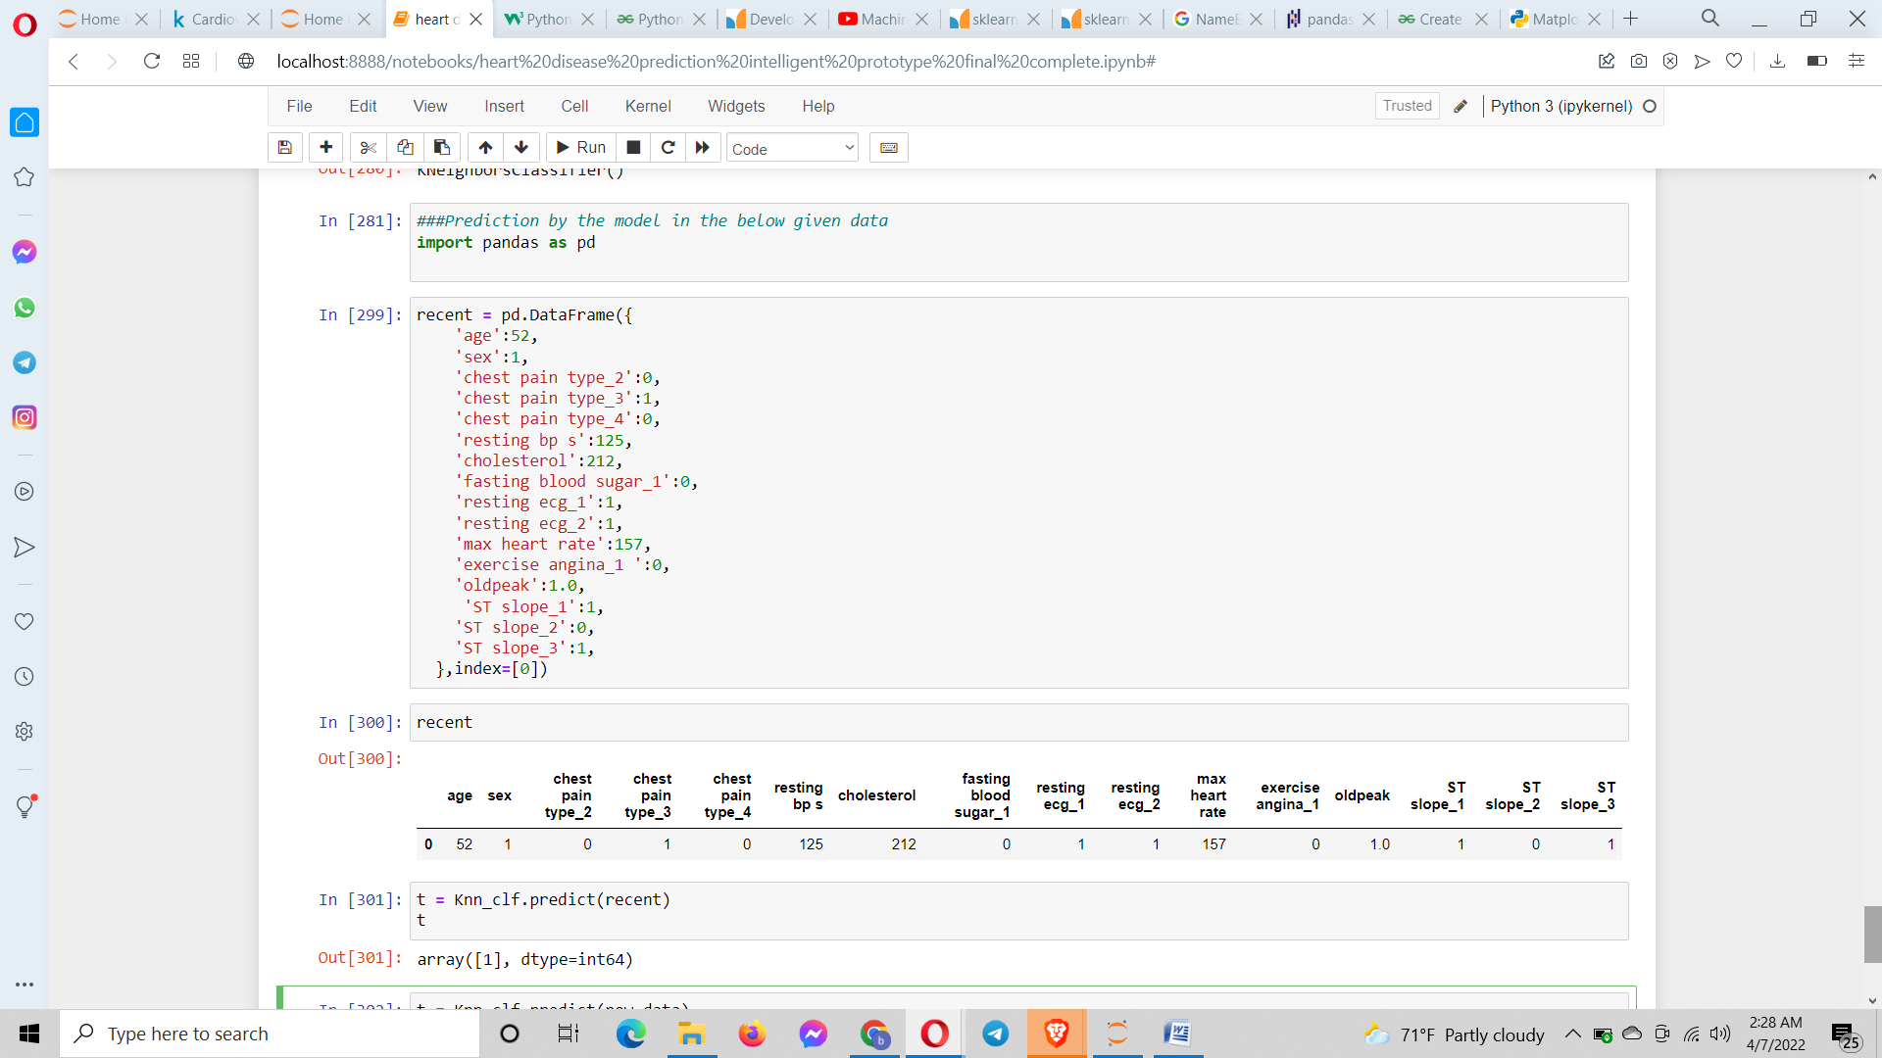

While predicting I got 1 as the output of t which clearly shows that there is a heart illness. If it had got 0 then there would be no illness. Then I created a program in which according to the value of t it displays output (Bhatt, Medium, 2021) .

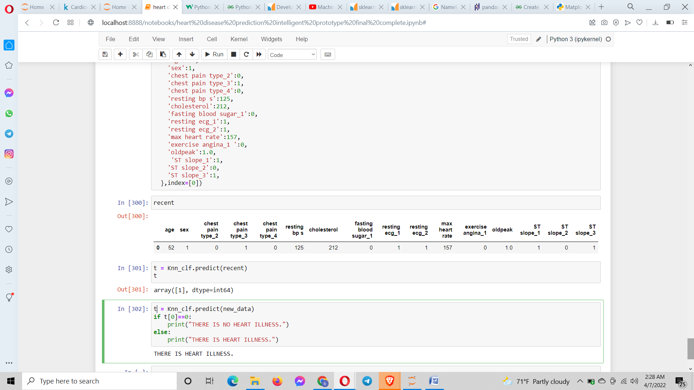

**Evaluation:**

The test plan for the evaluation of the heart disease prediction intelligent system I developed was:

1. Tuning the hyperparameters
2. Feature importance
3. Confusion matrix
4. Cross validation
5. Precision
6. Recall
7. F1 score
8. Classification report
9. ROC curve
10. Area under the curve (AUC)

I took KNN for the hyperparameter tuning. The hyperparameter tuning is used for the enhancing the accuracy of the model. In hyperparamter tuning the hyperparameters parameters are changed but not too much which will result in overfitting. Overfitting occurs when the training errors(errors occurred when the model is trained) are less and the test errors(errors occurred when the model is tested) are large.I imported the train_test_split class from the sklearn library. The dataset used is then splitted into X and y. The target variable(columns) was loaded into the y variable and the remaining variables were loaded into the X variable. The train_test_split () was used to split these data sets into training set and testing set. The KNeighborsClassifier class was imported from the sklearn library. The instance of the KNeighborsClassifier() was used to compute the score of the model. The score of any model as a default is accuracy and it was found out on the test data set and were found out to be higher.

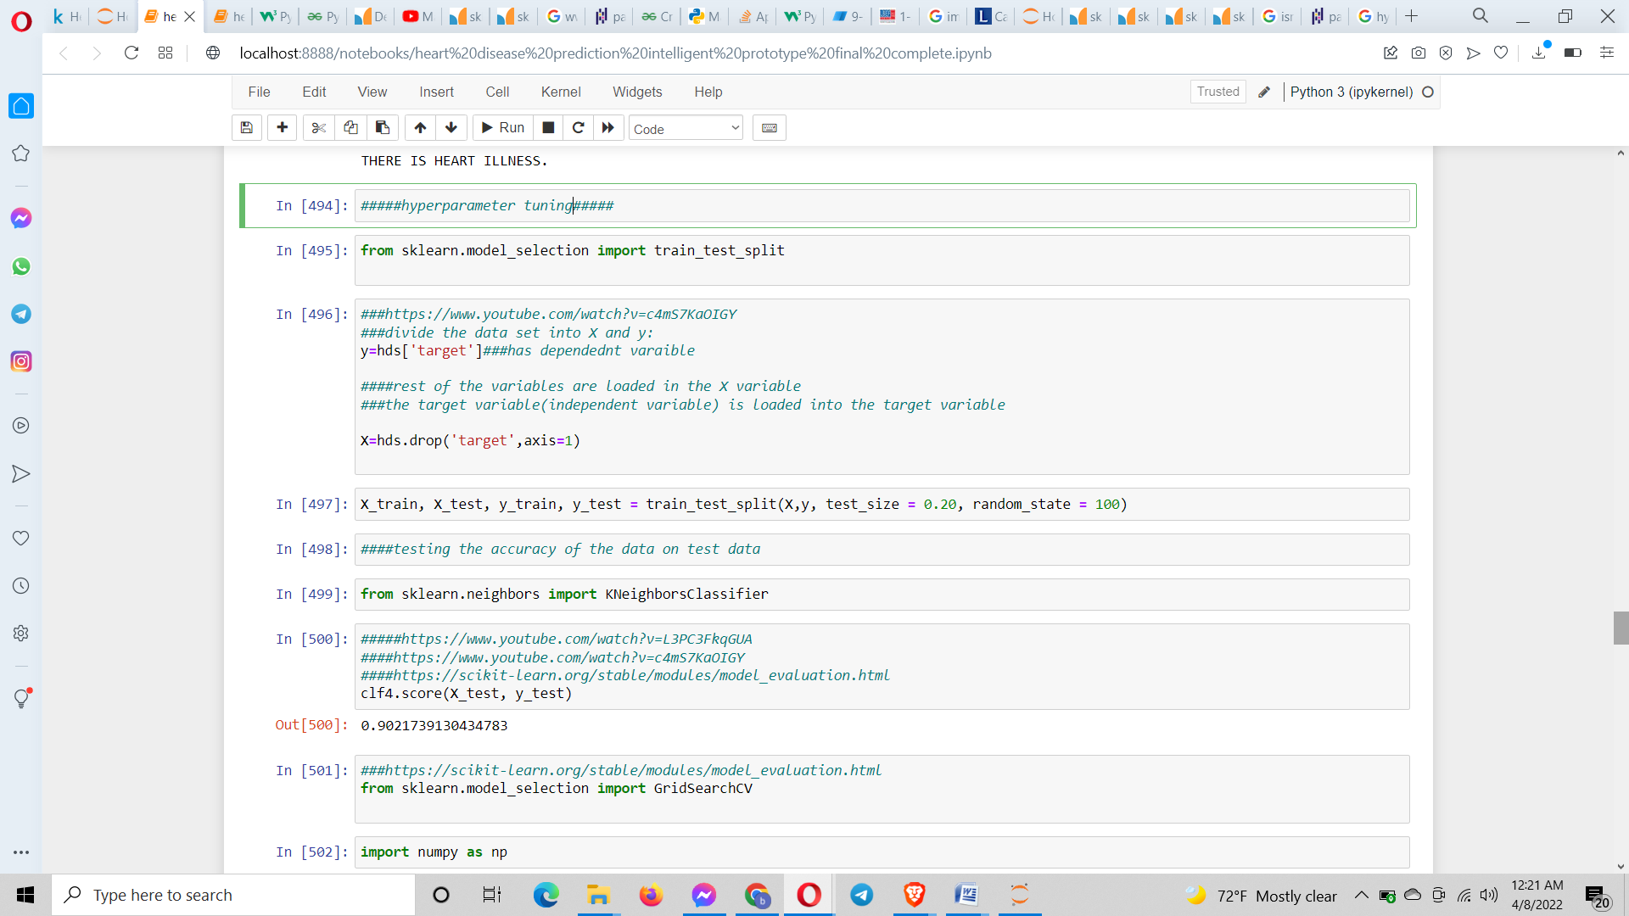

The hyperparameter tuning can be done by the GridSearchCV process which was used here. First the GridSearchCV class was imported from the sklearn library. Nneighbors is one of the parameters of the KNN. We can adjust/tune the KNN using the n_neighbors which is 5 by default. A dictionary of list of different values from 1 to 25 were created. So at each neighbor values the model is trained. The baseline score which was obtained from the default value of the hyperparameter obtained is improved by following this procedure. The numpy library was imported. The instantiation of the KNeighborsClassifier()was done. The gridsearchCV() was used which I gave the cross validation value of 10. Cross validation simply means that the data set is divided and at one time one part is taken as test set and other part was taken as train set and vice versa. The tuned model was given as a parameter to a as well as the dictionay. The [GridSearchCV](https://scikit-learn.org/stable/modules/generated/sklearn.model_selection.GridSearchCV.html#sklearn.model_selection.GridSearchCV) instance implements the usual estimator API: when “fitting” it on a dataset all the possible combinations of parameter values are evaluated and the best combination is retained. The model was fitted by the train data set because in the gridearchcv the fitting is essential. The best score and best params were found out. A note to remember the machine learning models are all evaluated on a test data set. The gridsearch cv is used in place of the cross validation technique since the later is pretty tedious when finding baseline scores for many values of C (Scikit learn) (Raj, 2019) .

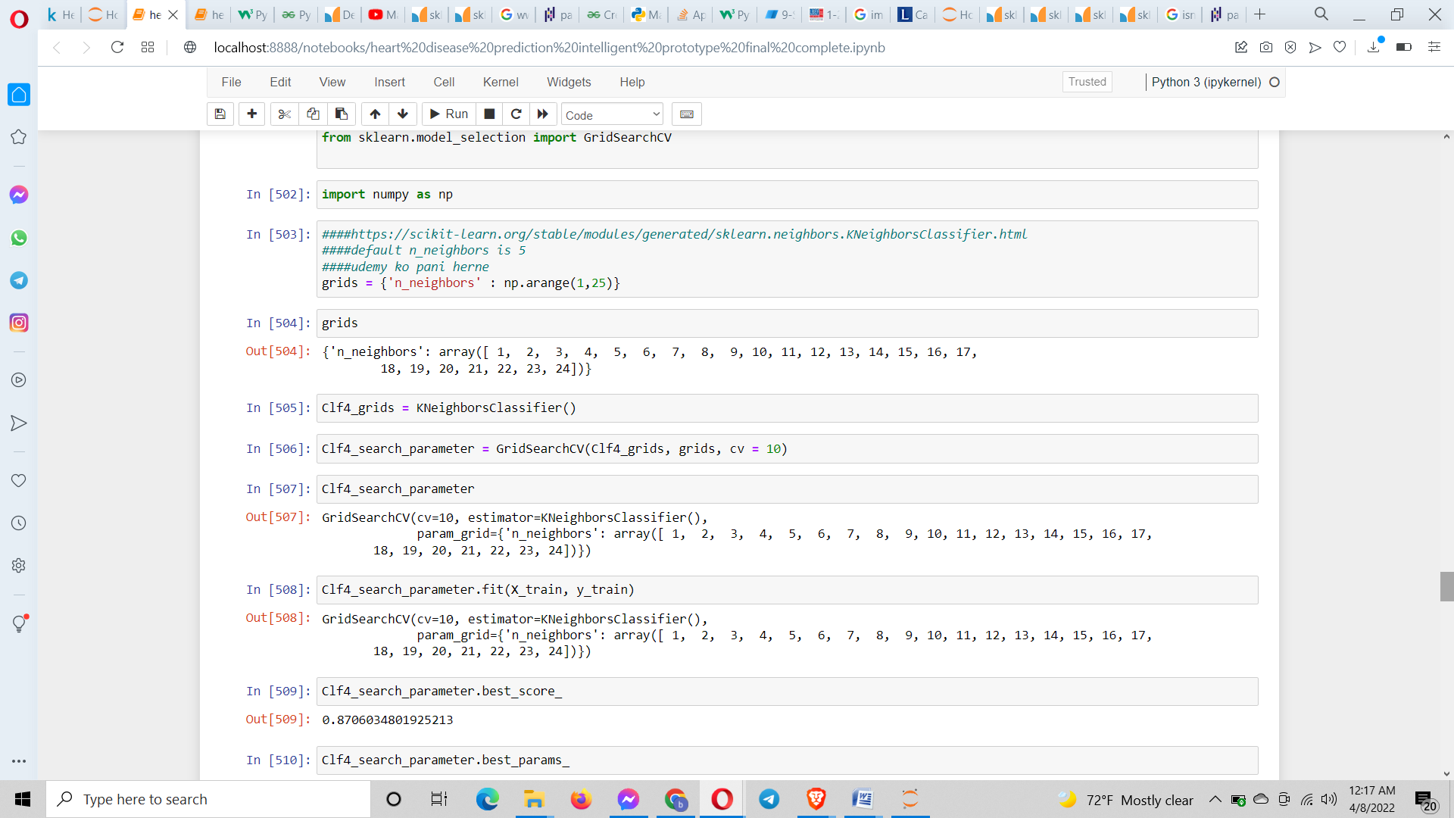

When comparing the data sets before and after hyperparameter tuning then substantial increase in the accuracy was resulted. This proved that hyperparameter tuning increased the accuracy of the model prediction.

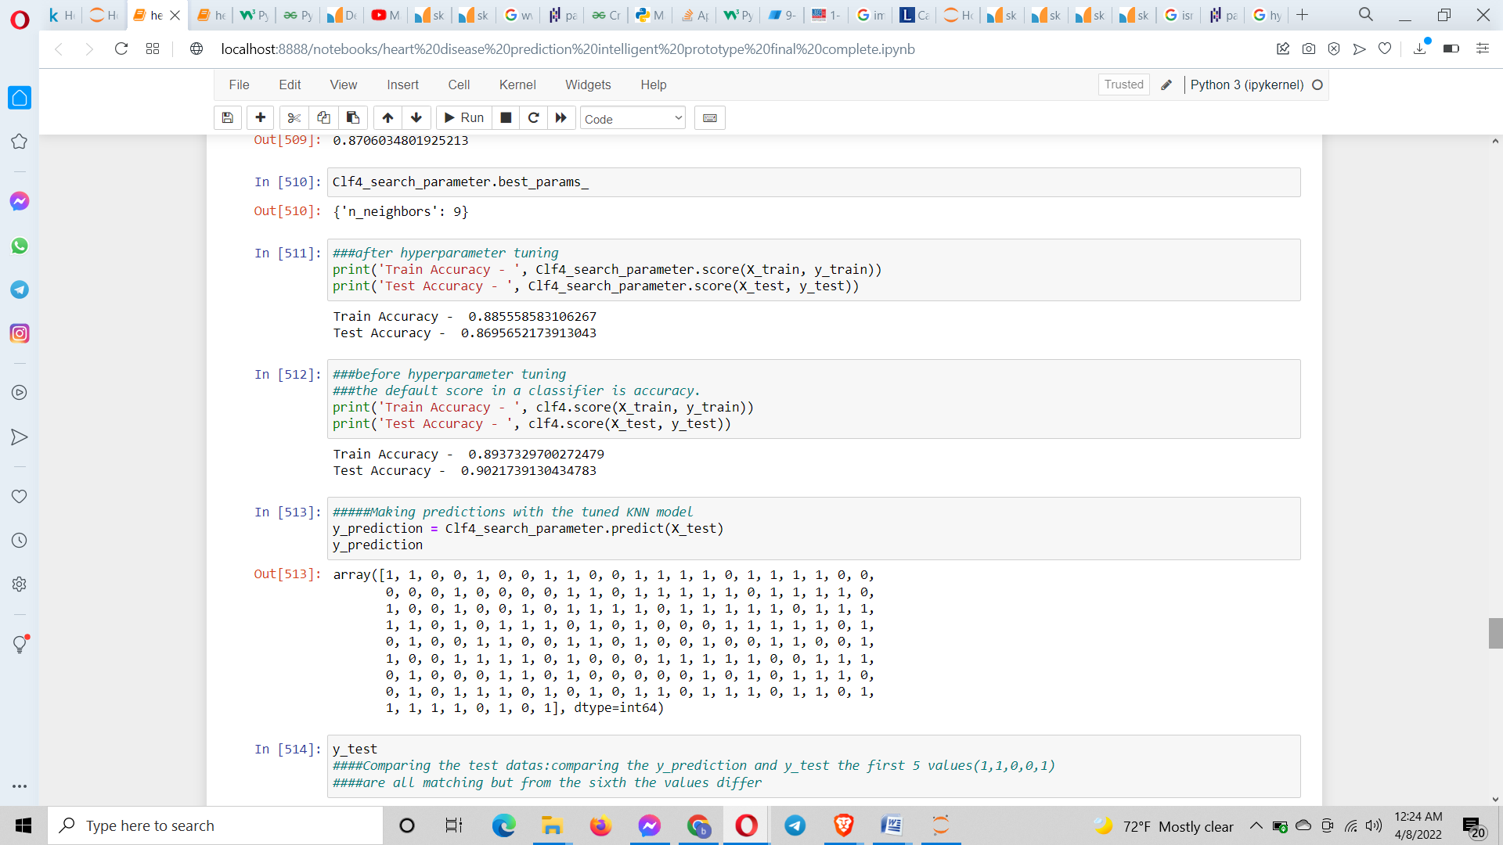

When the predictions were made then comparing the test datas from the 6th value the values started to vary. For further evaluation I used the ROC curve and confusion matrix for which I imported the plot_roc_curve and confusion matrix classes from sklearn library. When plotting the ROC curve the AUC was also displayed. The splitting of the data set was done and the model was fit. The Roc curve computes the AUC metric (ie. area under the curve). The AUC is calculated as 0.93. This value is a very good on indeed. The range of AUC is between 1 and 0. The more the AUC is closer to 1 the better the accuracy is of the model in prediction.

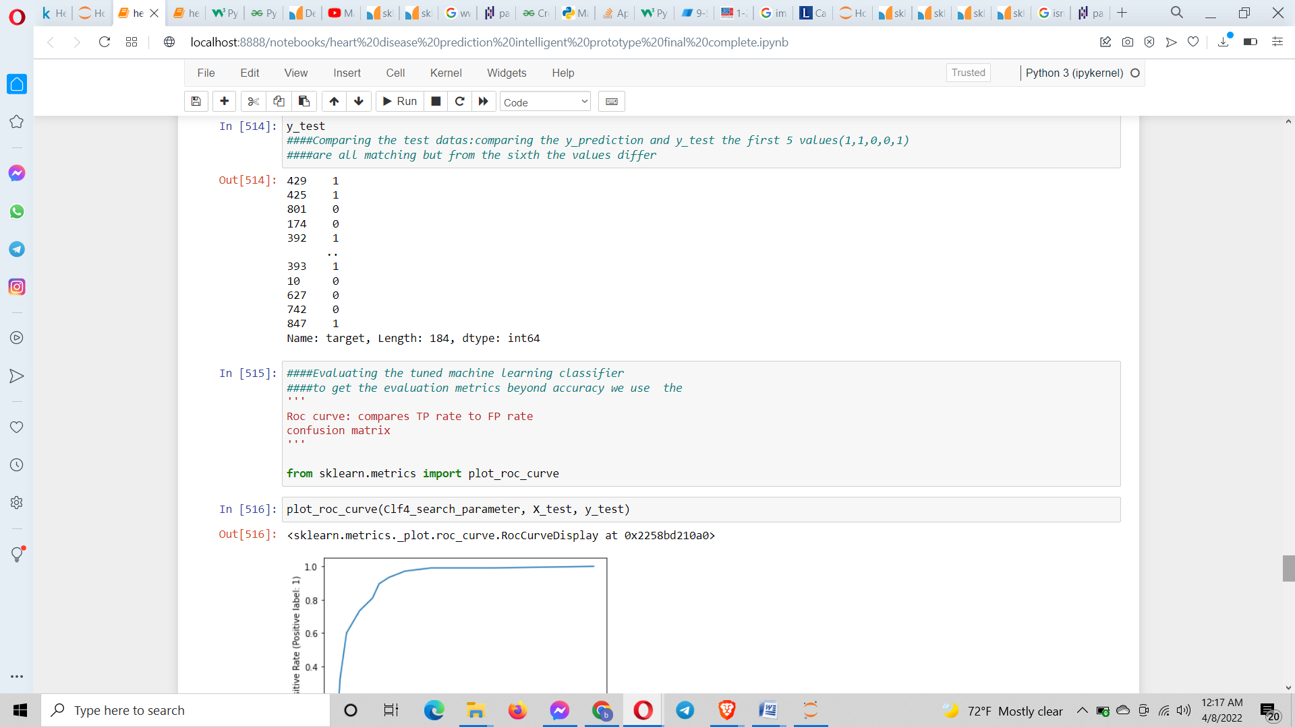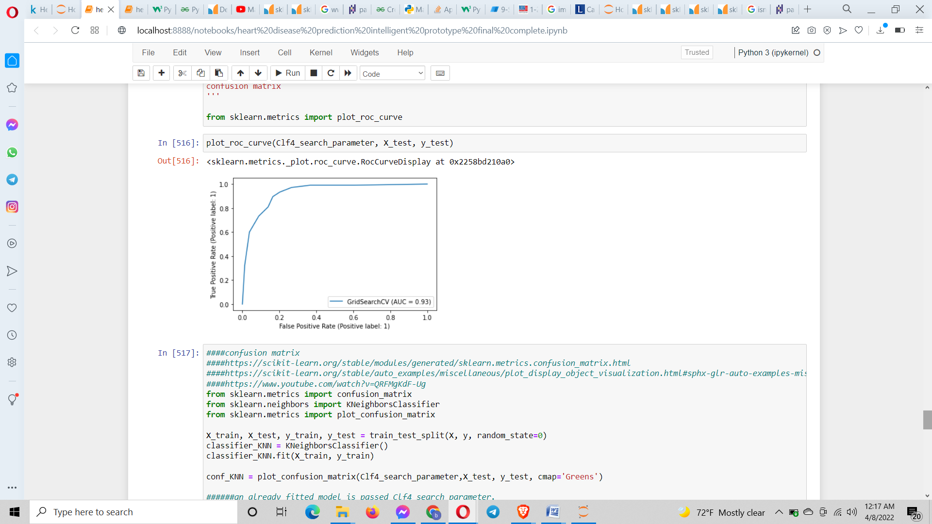

The plot_confusion_matrix() was used to plot the confusion matrix. The confusion matrix takes in the fitted model and predicts the test set X_test and compares the predicted output with the test set y_test internally which I did in a single code of line. In the presented confusion matrix:

When the true label was 1 then the patient had actually the heart disease

When the true label was 0 then the patient didn’t have the heart disease.

When the Predicted label was 1 then the model had actually predicted the heart disease present.

When the Predicted label was 0 then the model didn’t predict any heart disease present.

It can also be represented as,

TP FN

FP TN

We got,

TP = 71

FP = 11

FN = 21

TN = 127

Accuracy = TP+TN/Total or

Error rate = (1-Accuracy)

Analysing the confusion matrix, 127 data sets were predicted accurately as well as 71 data sets (coaching, 2020).

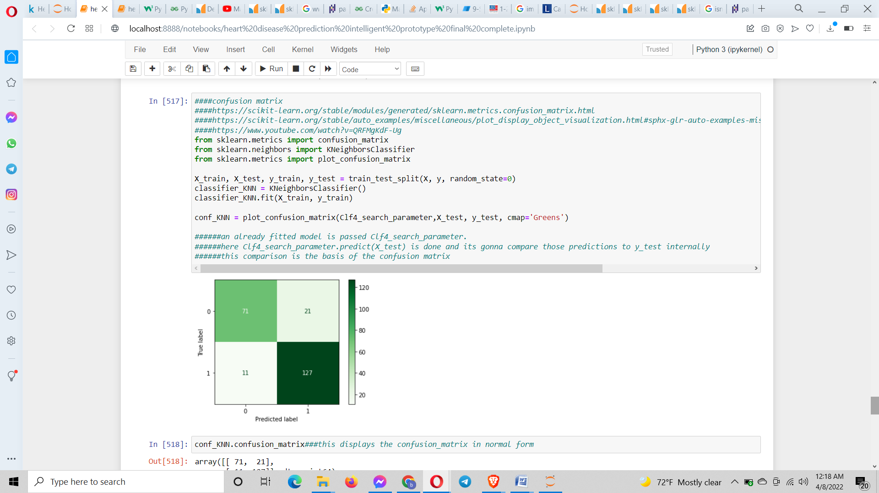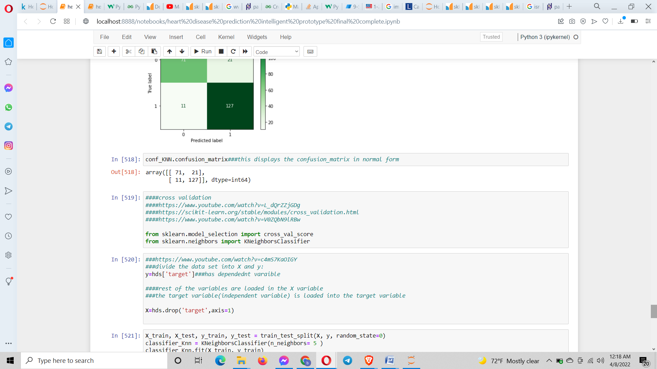

The cross validation was performed for which I imported cross_val_score class from sklearn library. This was carried out for 4 tyoes of scoring values(accuracy, f1, recall and precision). For it I constructed a program which computes these scores of the tuned model for each value of n_neighbor in the range provided. For this scoring value is given accordingly. The cv is given 10. The score values which are found out in these 4 cases are then appended to an empty list. Since the time for execution will take a long time so I only gave it a range of 1 to 3 so there are only 2 values displayed. When the cv is given the value 10 which Is a 10 fold cross validation, the data sets were divided into 10 equal blocks having equal values. In the 1st iteration the 1st block of data set was taken as test set and the remaining blocks were taken as train set data. In the 2nd iteration the 2nd block was taken as test data set and so on till the range of n_neighbor. Then the tuned model was trained on the training data set which was finally given the test data sets for prediction. The mean of the score values before appended was found out using the mean().The appended values are then displayed (engineering, 2018) .

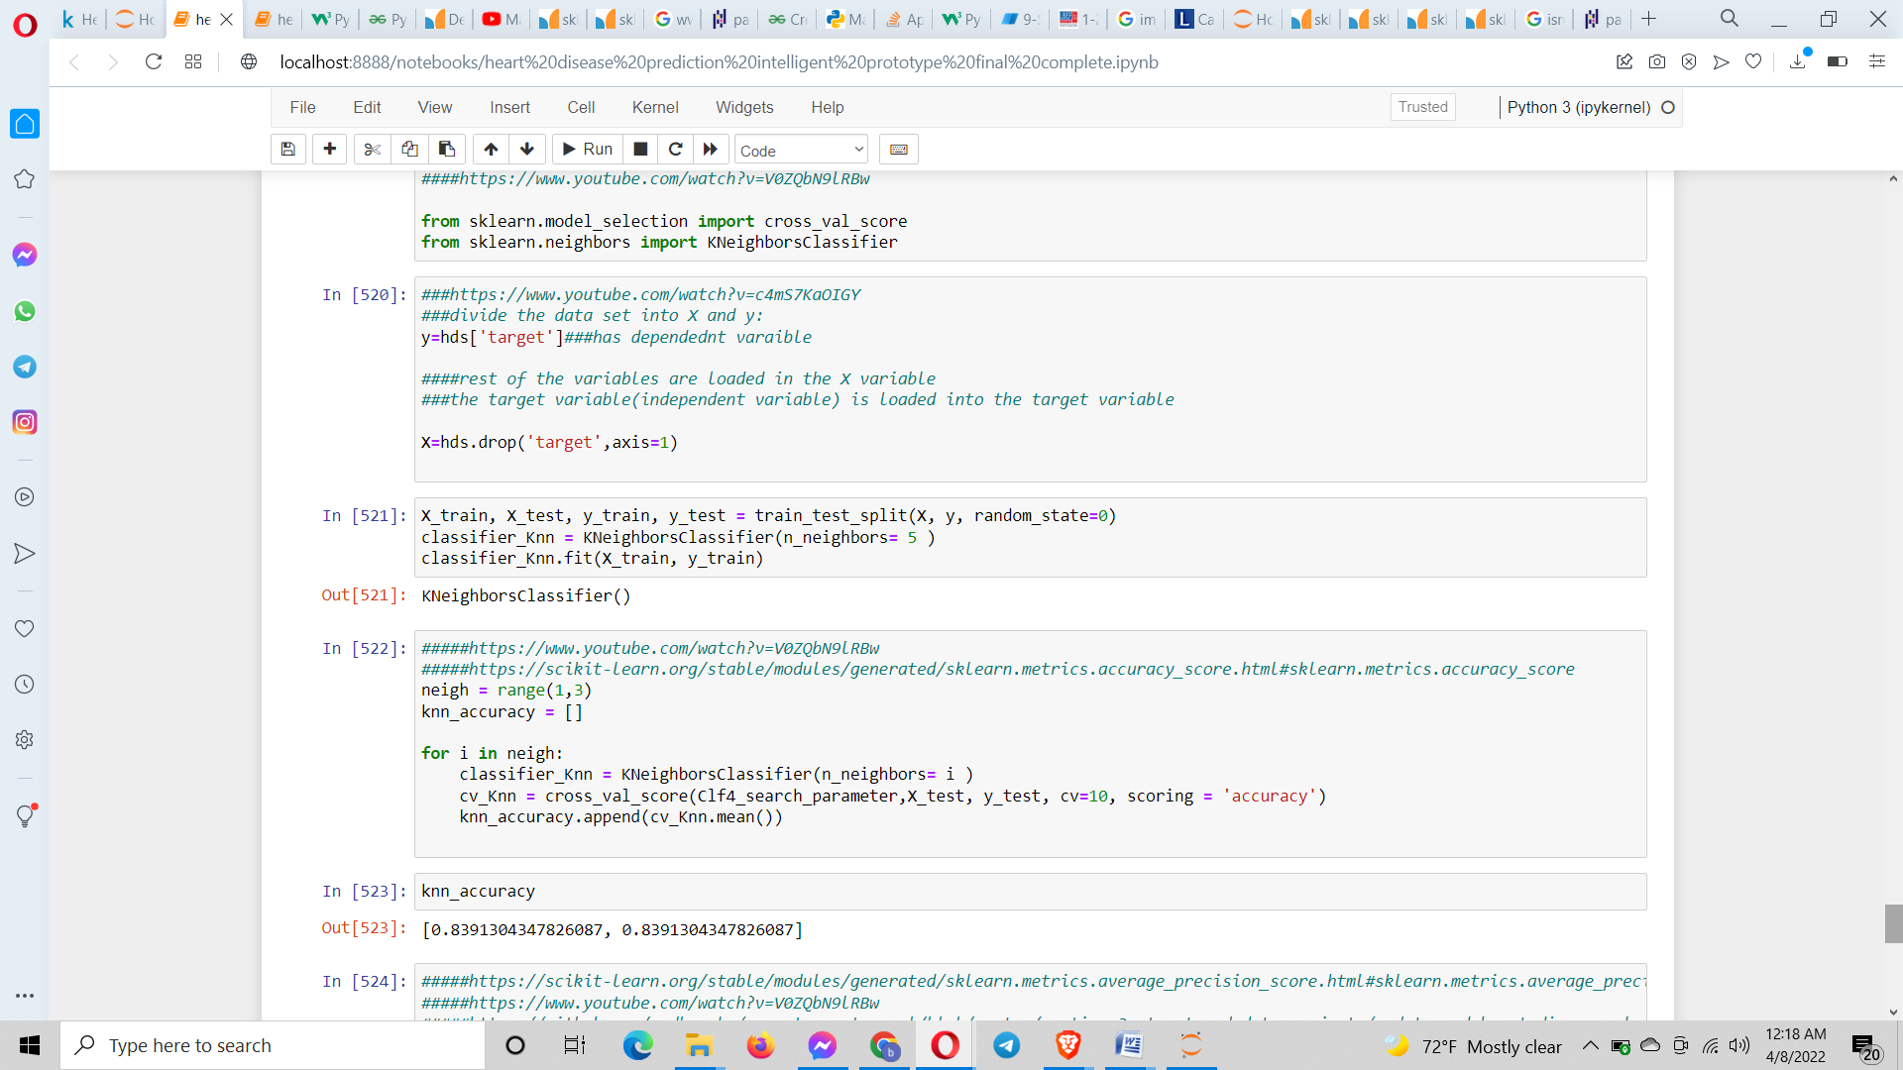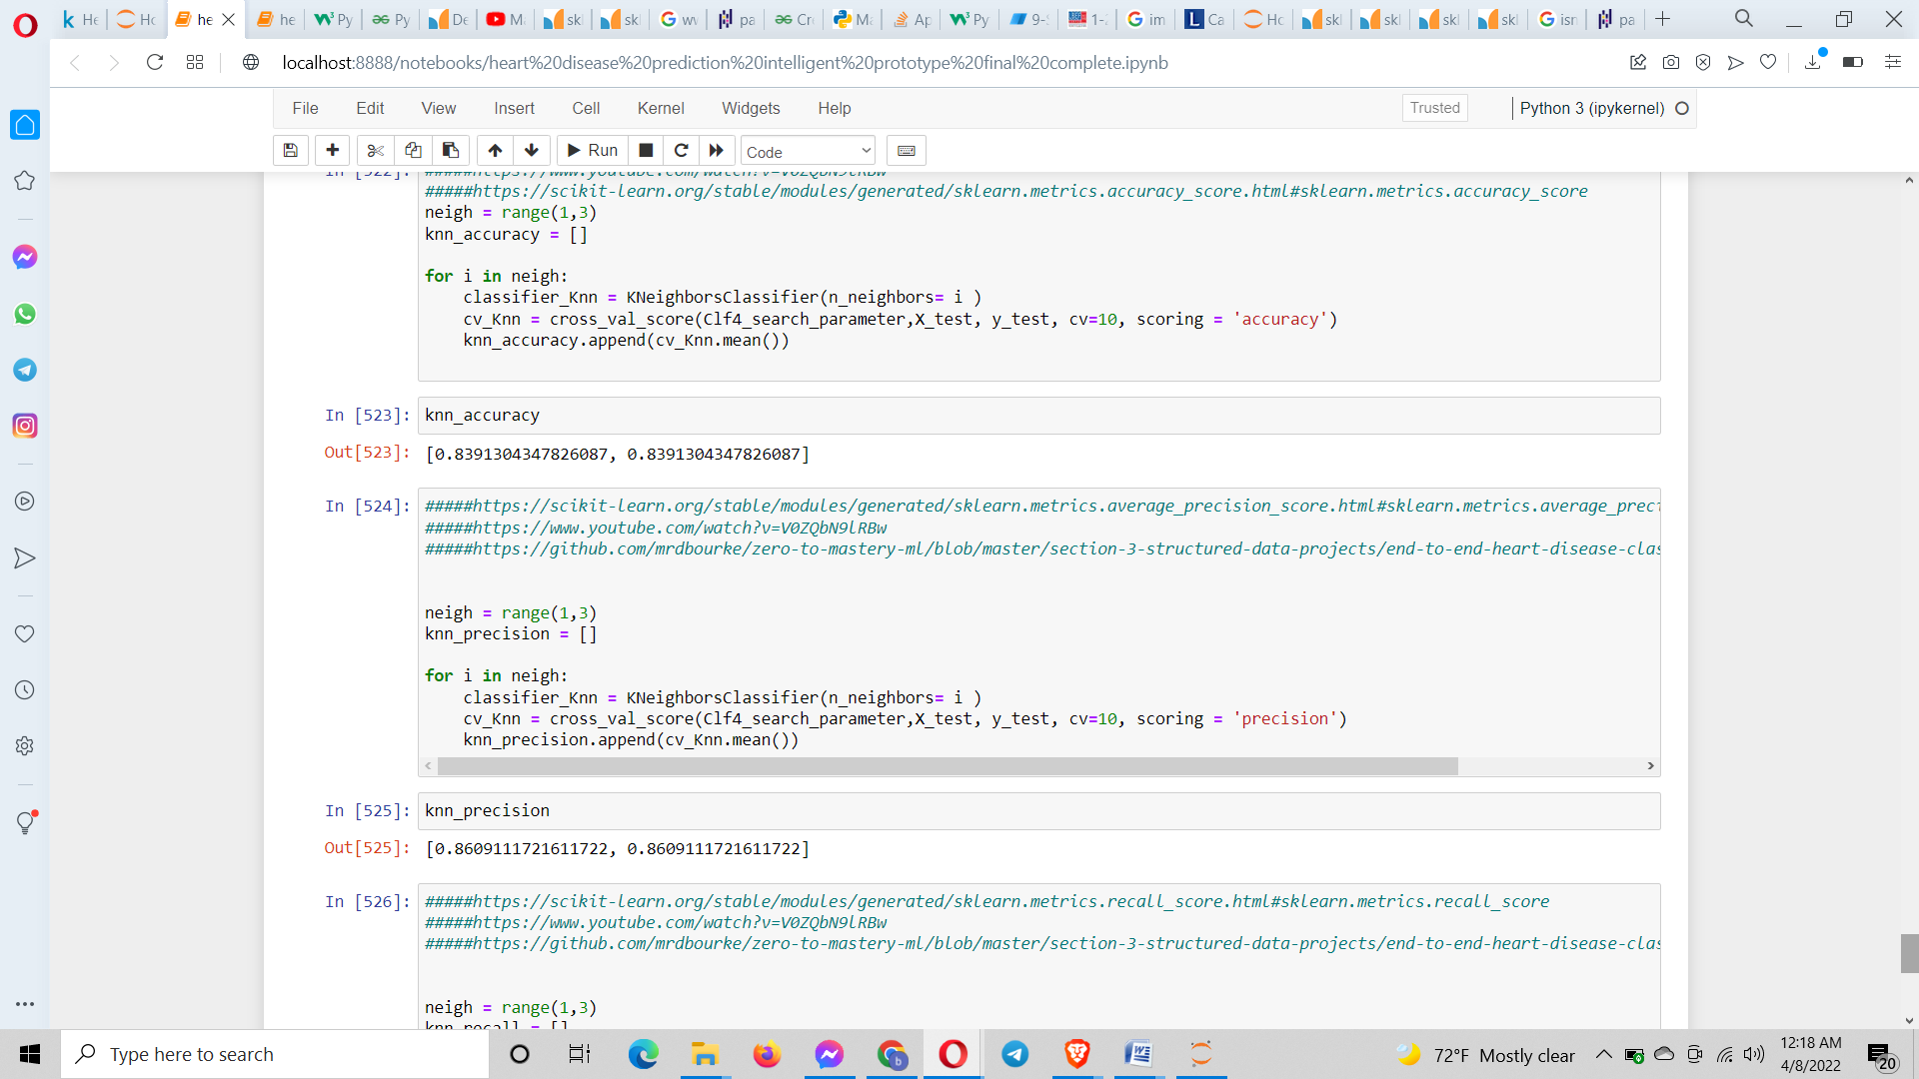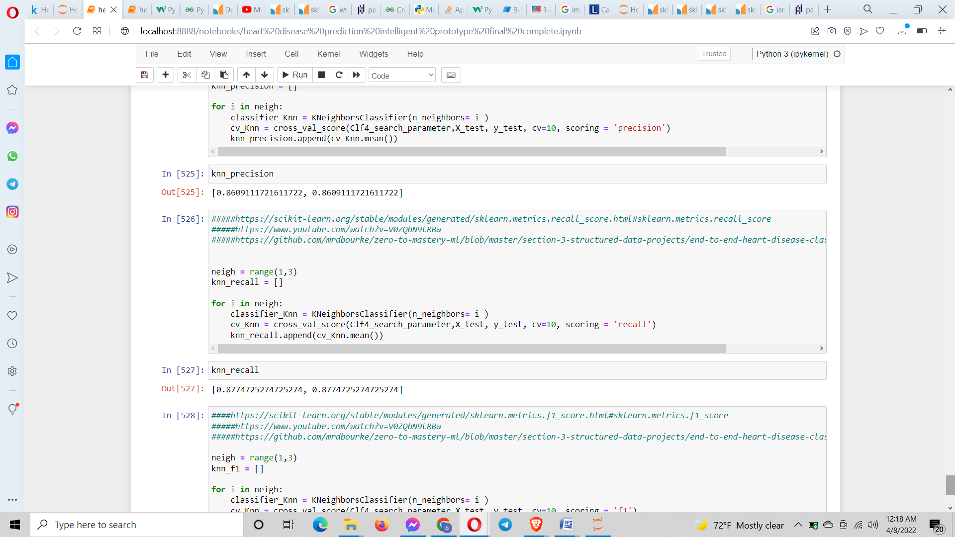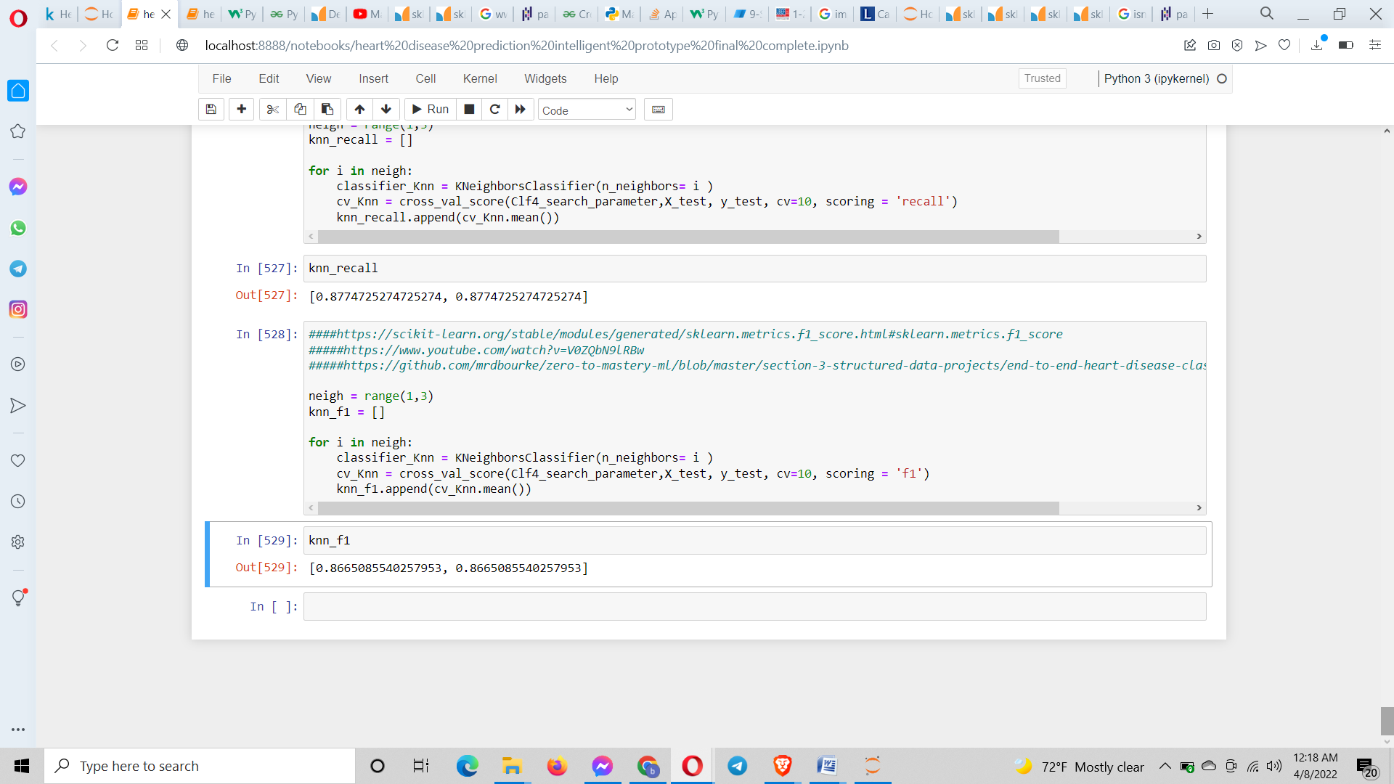

**Conclusion**:

After the identificiation of the problem statement, I planned in finding a solution through ML. I performed the literature review extensively via the internet. I located the way to solve the issue but I didn’t quite know which was the best algorithm to select so I went ahead and took 6 algorithms(logistic regression, svn, decision tree, random forest and k nearest neighbor) from which I eventually I got the same accuracy between the logistic regression and KNN. Hence I opted for KNN to carry on further with the work of improving the accuracy. The data set was downloaded from Kaggle. In one of the moudule exercise it required me to register an account in Kaggle so I was familiar to it. I wanted to perform the modeling on the biggest data set which I could find and I did(cardio_train.csv) and even used it on the model initially but somehow it was not preprocessing it well enough so I opted for the current data set.

Also, I took to Windows OS, Google Chrome Browser, Oracle browser and Brave browser to run my jupyter notebook on. There weren’t that many errors which I encountered most of them were just technical errors. For the most part the development of the project went as desired. Luckily there was a minor hardware failure at one point but it got resolved quickly and nothing had been lost. Python was taught in the module and it made the coding part that much easy. Whenever I got stuck anywhere I immediately went to the exercises present in the module syllabus or the internet. Words cant describe how much I have enjoyed this module since I am planning to pursue my career in the field of machine learning. I wanted a comprehensive course structure so that I can get my hands dirty in and by sheer luck the university had the exact thing I was looking for quite some time. Regarding the development of this prototype I have selected the Numpy, Pandas Matplotlib for data analysis and manipulation whereas for the machine learning section I have selected scikit learn. I am very proud of the last 3 months which I have spent on researching this module syllabus and have saved everything for future references of which I am confident I will come back to from time to time. The module teacher was a good communicator of words and it made it even more interesting.

This project development was done on waterfall model. I faced the issue of low accuracy which was mainly due to the size of the dataset. I will surely at some point fit a larger dataset in this model.

At last, I was able to get all the section of this project be running smoothly as required with no big issue and as a virtue of which I fulfilled what I had set out to achieve at first which was to build a machine learning intelligent prototype system which solves real world problem by successfully predicting the presence of heart disease in patient.

# Bibliography

(n.d.). Retrieved from https://pandas.pydata.org/docs/reference/api/pandas.unique.html

(n.d.). Retrieved from https://pandas.pydata.org/docs/reference/api/pandas.unique.html

(n.d.). Retrieved April 1, 2022, from Scikit learn: https://scikit-learn.org/stable/developers/develop.html

(n.d.). Retrieved April 1, 2022, from Scikit learn: https://scikit-learn.org/stable/modules/generated/sklearn.metrics.accuracy_score.html

(n.d.). Retrieved April 1, 2022, from Scikit learn: https://scikit-learn.org/stable/modules/generated/sklearn.linear_model.LinearRegression.html

(n.d.). Retrieved April 1, 2022, from Scikit learn: https://scikit-learn.org/stable/modules/generated/sklearn.svm.SVC.html

(n.d.). Retrieved April 1, 2022, from Scikit learn: https://scikit-learn.org/stable/modules/generated/sklearn.ensemble.RandomForestClassifier.html

(n.d.). Retrieved April 1, 2022, from Scikit learn: https://scikit-learn.org/stable/modules/generated/sklearn.neighbors.KNeighborsClassifier.html

(n.d.). Retrieved April 1, 2022, from scikit learn: https://scikit-learn.org/stable/modules/generated/sklearn.tree.DecisionTreeClassifier.html

(n.d.). Retrieved april 1, 2022, from Stack overflow: https://stackoverflow.com/questions/14860460/append-several-variables-to-a-list-in-python

(n.d.). Retrieved April 1, 2022, from Scikit learn: https://scikit-learn.org/stable/modules/grid_search.html

(n.d.). Retrieved april 1, 2022, from Pandas: https://pandas.pydata.org/docs/reference/api/pandas.DataFrame.describe.html

(n.d.). Retrieved april 1, 2022, from Pandas: https://pandas.pydata.org/docs/reference/api/pandas.DataFrame.info.html

(n.d.). Retrieved April 1, 2022, from Pandas: https://pandas.pydata.org/docs/reference/api/pandas.DataFrame.head.html

(n.d.). Retrieved april 1, 2022, from plus2net: https://www.plus2net.com/python/pandas-dataframe-isnull.php

(n.d.). Retrieved april 1, 2022, from Pandas: https://pandas.pydata.org/docs/reference/api/pandas.DataFrame.nunique.html

(n.d.). Retrieved april 1, 2022, from Pandas: https://pandas.pydata.org/docs/reference/api/pandas.unique.html

(n.d.). Retrieved april 1, 2022, from ask python: https://pandas.pydata.org/docs/reference/api/pandas.unique.html

(n.d.). Retrieved april 1, 2022, from w3schools: https://www.w3schools.com/python/pandas/ref_df_nunique.asp#:~:text=The%20nunique()%20method%20returns,unique%20values%20for%20each%20row.

(n.d.). Retrieved april 1, 2022, from Pandas: https://pandas.pydata.org/docs/reference/api/pandas.Series.nunique.html

(n.d.). Retrieved april 1, 2022, from Pandas: https://pandas.pydata.org/docs/reference/api/pandas.DataFrame.duplicated.html

(n.d.). Retrieved april 1, 2022, from pandas: https://pandas.pydata.org/docs/reference/api/pandas.isnull.html

(2020, July 16). Retrieved April 1, 2022, from Kunal Naaik: https://www.youtube.com/watch?v=c4mS7KaOIGY

Bhatt, P. (2021, December 23). Retrieved April 1, 2022, from Medium: https://medium.com/@priyangbhattce/heart-disease-prediction-using-machine-learning-155a1c2e5f23

Bhatt, P. (2021, December 23). Retrieved April 1, 2022, from Medium: https://medium.com/@priyangbhattce/heart-disease-prediction-using-machine-learning-155a1c2e5f23

Bhattarai, S., & Aryal, A. (2020). Cardiovascular disease trends in Nepal – An analysis of global burden of disease data 2017. *Elsevier* .

Chudasama, R. (2021, August 12). Retrieved from geek culture: https://medium.com/geekculture/data-science-series-ep-2-e5fa1a463654

Chudasama, R. (2021, August 12). Retrieved April 1, 2022, from Geek culture: https://medium.com/geekculture/data-science-series-ep-2-e5fa1a463654

coaching, K. (2020, August 26). Retrieved April 1, 2022, from Youtube: https://www.youtube.com/watch?v=5LqrQfWn9Es&t=7s

*Data visualization*. (n.d.). Retrieved from http://python.mykvs.in/programs/programs2021/class%20xii/ip/dvp.pdf

engineering, 5. m. (2018, December 7). Retrieved April 1, 2022, from Youtube: https://www.youtube.com/watch?v=poKFir0QGCI

*Heart disease Dataset (Comprehensive)*. (n.d.). Retrieved 2022, from www.kaggle.com: https://www.kaggle.com/datasets/sid321axn/heart-statlog-cleveland-hungary-final

Jindal, H., Agrawal, S., Khera, R., Jain, R., & Nagrath, P. Heart disease prediction using machine learning algorithms. *IOP Conference Series: Materials Science and Engineering.* IOP Publishing.

k, S. (2021, June 02). Retrieved April 1, 2022, from geeks for geeks: https://www.geeksforgeeks.org/create-a-pandas-dataframe-from-lists/

k, S. (2022, March 31). Retrieved april 1, 2022, from Geeks for geeks: https://www.geeksforgeeks.org/how-to-get-column-names-in-pandas-dataframe

Kartikayabhutani. (2018, september 17). Retrieved april 1, 2022, from Geeks for geeks: https://www.geeksforgeeks.org/python-pandas-series-unique/

Raj, R. (2019, July 28). Retrieved April 1, 2022, from Youtube: https://www.youtube.com/watch?v=WxINg-eof2M

Reddy, V. V., & Elamvazuthi, I. (2021). Heart disease Risk Prediction Using Machine Learning Classifiers with Attribute Evaluators. *Applied Sciences* .

sid312axn. (2020, September 9). Retrieved april 1, 2022, from Github: https://github.com/sid321axn/Heart-Disease-Prediction-Using-Machine-Learning-Ensemble

sid321axn. (2020, September 9). Retrieved april 1, 2022, from github: https://github.com/sid321axn/Heart-Disease-Prediction-Using-Machine-Learning-Ensemble/blob/master/heart_statlog_cleveland_hungary_final.csv

*Youtube*. (2018, october 16). Retrieved april 1, 2022, from Free udemy course: https://www.youtube.com/watch?v=W5wo3KIUuw4